ANALYSIS 1

An Outline of the Problem 1

Potential Problems 1

Potential Bugs 1

Potential Solutions 1

Limitations of Enigmas Odyssey 1

Possible Solutions 1

Research 1

Potential Stakeholders 1

Stakeholder Pre-Trial Questions 1

Interview-1 Rudy Lee 1

Interview-2 Aaron Gregory 1

Interview Review 1

How the problem can be solved by computational methods 1

Thinking Abstractly 1

Thinking Ahead 1

Thinking Procedurally 1

Thinking Logically 1

Thinking Concurrently 1

Conclusion 1

Success Criteria 1

Hardware and Software requirements: 2

Hardware Requirements: 2

Software Requirements: 3

Time Limitations 4

Hardware Limitations 4

Game Research From Other Similar Games 4

Research into Brawlhalla: 4

Research Into Different Puzzle Solving Games 4

Research Into My Theme 4

Research Into Terraria 4

Design 4

Systems Diagram 4

Explanation of Each Module 4

Usability Features 4

Classes 4

Algorithms 4

Key Data Structures and Variables 4

Test Data 5

Acceptance testing 5

Developing the Coded Solution 7

Choosing the correct Game Lab 7

Learning C# 7

Learning the Game Lab Environment 7

Searching and looking for Sprites 7

Creating a Platform and Using My Sprite 7

Moving Left and Right 7

Flipping the Character 7

Jumping 7

Camera Movement 7

Creating My Puzzle 7

Method for cutting up image 7

Adding Difficulty Levels 7

Making An Object to Hold the Puzzle 7

Fixing the camera 7

Adding Features to my Puzzle 7

Adding a Score Counter 7

Scenes 7

Audio 7

UI 7

Menu- Play Button 7

Menu- Difficulty Panel 7

Menu- Settings Panel 7

Settings Panel- Volume Slider 7

Settings Panel- Brightness Slider 7

Menu-Cancel Button 7

Menu- Quit Game Button 7

Splash Screen 7

End Game Screen 7

Designing the stage 7

Animations 7

Implementing Animations 7

Refinement 7

Evaluation 7

Usability Features 7

Menu Navigation 7

Difficulty Selection 7

Puzzle Interaction 7

High Score System 7

Camera Switching 7

Game Completion Feedback 7

Stakeholder Post-trial Questions 7

Interview-1 Aryan Soni 7

Interview-2 Daniel Forey 7

Testing For the Evaluation 7

Issues Identified and Potential Improvements 8

Difficulty Selection Not Updating Properly 8

Lack of Smooth Transitions for Camera Switching 8

No visual/ audible feedback for puzzle completion 8

Brightness slider doesn’t work 8

Move count not resetting after reshuffle 8

Menu Navigation with keyboard not implemented 8

To what extent does the solution meet the success criteria? 8

Testing- “Connell Dawson” 9

Maintenance 9

Current and Future Maintenance 9

Limitations and How They Would Be Approached 9

References 10

# ANALYSIS

## An Outline of the Problem

Enigma's Odyssey differs from games like Assassin's Creed by offering a unique gameplay experience focused on puzzle-solving and exploration within ancient civilizations. While Assassin's Creed is known for its open-world, combat-oriented gameplay set in immersive 3D environments, Enigma's Odyssey takes a different approach with its 2D perspective, puzzle-centric mechanics, and level-based structure.

### Potential Problems

Both "Assassin's Creed" and "Enigma's Odyssey" might encounter challenges in running smoothly on different devices, making the game too hard or confusing for players, keeping the story interesting while still making the game fun to play, balancing different parts of the game so players don't get bored, and fixing any mistakes or glitches that pop up during development.

### Potential Bugs

In addition to optimization and gameplay concerns, both "Assassin's Creed" and "Enigma's Odyssey" may encounter bugs and glitches during development, leading to unexpected crashes, visual anomalies, or gameplay interruptions.

### Potential Solutions

To address these issues, I can utilize tools to ensure the game runs smoothly on all devices, listen to feedback from players to make the game easier to understand, carefully plan out the story and gameplay to keep players interested, balance different parts of the game to maintain engagement, and test the game extensively to identify and fix any mistakes or glitches promptly.

To fix these issues, I will thoroughly test the game to find and fix any bugs before it is released. I will also keep good records of any changes and listen to feedback from players to make sure the game runs smoothly and is enjoyable to play. By paying attention to detail and being careful, I can ensure that players have a wonderful experience with the game.

### Limitations of Enigmas Odyssey

-The problem might extend past the given time

-Adding too many features may make my code unmanageable, more complex, and difficult to read

- The puzzles might be too easy or too difficult, leading to frustration or boredom for players.

- Players might find it hard to go through the menu or understand the interface in-game.

-The game might become repetitive if there are not enough puzzles, which leads back to the first problem that if I were to add more puzzles it would extend past the given time

-The game might not be compatible with all operating systems.

-Finding enough people to carry out effective testing might be difficult

-Limited knowledge of developing games on tools like PyGame can cause slow progress when developing the game.

### Possible Solutions

-In order to reduce how much time is spent on creating the game, I can remove unnecessary features such as having too many puzzles.

-I can make my code easier to read by adding indentations and comments to my code to outline the purpose of each code is.

- I will add difficulty levels to make my game enjoyable for everyone.

-There will be a help section if there is a problem with navigating around the game.

- I will constantly update my game to add different puzzles, to make it more exciting and reduce repetition.

-I can adapt my game to make it compatible with every operating system such as IOS or Windows.

-I can give people in my class, my game to play and try so that they can give me feedback on what to improve on.

-I have been doing coding projects outside of my NEA on PyGame so that I am able to use PyGame fluently and effectively.

## Research

### Potential Stakeholders

1.Players:

Players are the heart of any game. They are the ones who play and enjoy Enigma's Odyssey. Their feedback is incredibly important because they are the ones who will be spending their time and money on the game. By listening to what players like and do not like, the developers can make the game better and more enjoyable for everyone.

2. Publishers:

Publishers are like the promoters of Enigma's Odyssey. They are the ones who help get the word out about the game and make sure that it reaches as many players as possible. They do things like marketing the game, arranging for it to be sold in stores, and sometimes even providing funding to help make the game in the first place. Their job is to make sure that Enigma's Odyssey gets the attention and recognition it deserves so that players everywhere can discover and enjoy it.

3. Testers:

Testers are like the quality control experts of Enigma's Odyssey. Their job is to play the game before it is released to the public and look for any problems or bugs that need to be fixed. This could be anything from a glitchy animation to a game-breaking bug that crashes the whole thing. By finding and reporting these issues, testers help ensure that "Enigma's Odyssey" is as polished and bug-free as possible when it is released.

4.Investors:

Investors are the people who provide the money to make Enigma's Odyssey possible. They invest their money in the hope of making a profit once the game is released and starts selling. Without investors, it would be challenging for me to turn my ideas into reality. So, investors play a crucial role in bringing "Enigma's Odyssey" to life.

5. Player Communities:

Player communities, like online groups or fan clubs, are places where fans of Enigma's Odyssey can hang out, talk about the game, and give feedback. By joining these groups, I can hear about any problems with the game or ideas for making it better, which supports me in improving Enigma's Odyssey for everyone.

6. Competitors:

Competitors are other game developers or publishers who make games like Enigma's Odyssey. What they do can affect how well my game does. By keeping an eye on them, I can stay competitive and make smart decisions to improve Enigma's Odyssey.

7. Content Creators:

Content creators, like streamers, YouTubers, or bloggers, make and share stuff about Enigma's Odyssey, such as gameplay videos, reviews, or tutorials. This helps get the word out about the game and reach more people.

### Stakeholder Pre-Trial Questions

(Given to people before the creation of Enigma’s Odyssey)

1) Would you prefer a linear progression through levels or more open-world exploration?

2) How important is story to you in a puzzle-solving game?

3) How difficult should the puzzles be to feel both challenging and rewarding?

4) How important is it that each puzzle is connected to the world’s theme (e.g., hieroglyphics in Ancient Egypt)?

5) What kind of hints or guidance would you like to receive if you get stuck on a puzzle?

6) Would you prefer puzzles that have multiple solutions, or should there be one specific solution?

7) How important is the ability to customize controls?

8) Would you like the ability to interact with objects in the environment, and if so, how?

9) Would you prefer stylized 2D art or a more realistic design for the game?

10) How important is it for the game’s music and sound effects to relate to the world you are exploring?

11) Would you like to see health bars, inventory slots, or just minimal information displayed?

12) Would you prefer in-game tutorials or optional tutorials you can access when needed?

13) How long should each level take to complete in a puzzle-solving game?

14) What do you think would make a puzzle-solving game like this stand out from others?

15) Are there any games you've played before that have a feature you would love to see included in this one?

16) If you were to suggest one feature that would make the game more enjoyable, what would it be?

#### Interview-1 Rudy Lee

Playing puzzle solving games for 2 years, programmer

1) Linear world progression would be more efficient as open world could get a bit complicated and too difficult depending on the type of game and environment.

2) Not much, this is due to the nature of a puzzle-solving game. A hint of story might be a good idea just as context to why we are solving the puzzles

3) They should increase in difficulty after each level, however you could try to implement a program which would calculate a suggested difficulty for different users.

4) It is very important for the puzzles to be connected to the world's theme as it will make it more educational and fun to play depending on the target audience.

5) A normal clue or riddle will be simple and efficient for the game as it will not reveal too much of the puzzle and will allow the player to get engaged into the gameplay when solving the puzzles using the clues.

6) I think that having one specific solution would be a better idea as it could promote collaboration between users to work towards one answer

7) The ability to change volume is most important to me

8) No.

9) Stylized 2D art would be easier and visually appealing for a game

10) Very important as it allows for me to feel immersed in the game

11) Minimal information as it would be much easier to focus on the puzzles

12) Optional tutorials will be more suitable since most players usually skip the tutorial of the game.

13) A timer should be set for each level based on the difficulty of the puzzle. This will make the game challenging for player, thus engaging them in the game.

14) The world's theme of the puzzle-solving game will make it stand out from the other puzzle solving games as it will make the game seem of adventure genre.

15) Spider-Man PS4 having connect the voltages correctly

16) Optional puzzles which would reward you with a specific item, and a counter for how many of those items you have collected. These optional puzzles should be more difficult than the normal puzzles.

#### Interview-2 Aaron Gregory

Experienced programmer, game designer and been playing puzzle solving games for years.

1) Linear world progression would be more efficient as open world could get a bit complicated and too difficult depending on the type of game and environment.

2) Not that important as the puzzles themselves are the most important thing

3) If the game has a story, the puzzle should be connected to the story in some way. Else, the puzzles should get difficult by each level for the player to enjoy the game as they progress.

4) If there is a theme included, I believe that the puzzles should have at least some connection if not then what is the point of introducing a world theme

5) Something that would help progress to the next point in the level. E.g. A suggestion of a move to make

6) Puzzles with simple solutions will be simple but equally engaging as the puzzles with multiple solutions. Since, puzzles with multiple solutions allow the player to highly get engrossed into the game and replay the levels to come up with different solutions.

7) Not very important

8)No

9) 2D Art Style for Puzzles

10) The game's music will be a crucial element since it will give a more realistic approach to the world's theme.

11) A timer would be more suitable than a health bar since it is a puzzle solving game. however, if there re enemies, then a health bar will be suitable.

12) Optional, allows users to progress through the puzzles if they have done something similar before

13) Each puzzle should take at least 5 minutes depending on what type of puzzle it is

14) The world's theme of the puzzle-solving game will make it stand out from the other puzzle solving games as it will make the game seem of adventure genre.

15) No

16) Cool Level Design

## Interview Review

These interview questions were created for me to get an understanding of what my stakeholders and users are looking for within my game. The main idea I noticed that the stakeholders were looking for is that they want a simple and easy game to play, but want an enjoyable and interactive one at the same time.

From what my stakeholders have said, these are features that I will be adding into my game to make it enjoyable and more playable:

* I will be making it a Linear progression as it is evidently easier to understand and navigate through
* I will change the puzzles from generic puzzles to making them related to the world theme such as translating hieroglyphics for ancient Egypt.
* A help tab for each puzzle on the top of the screen
* Single solutions to each puzzle
* 2D art style
* There will be music throughout the game from when you load into it to the end.
* A timer when you start the puzzle that pops up in the top.
* I will make the puzzles longer.
* Add optional help buttons for when users are stuck on a puzzle.

## How the problem can be solved by computational methods

Decomposition breaks tasks into parts to help me focus. Thinking ahead plans for problems early. Procedural thinking organizes tasks step by step. Concurrent thinking lets me do many things at once, making work faster. These methods help me solve problems and work better on making games. By using these strategies, I can handle difficult challenges and improve performance.

### Thinking Abstractly

Thinking abstractly for this project involves simplifying Enigma's Odyssey to fit within a 2–3-month time period. I will prioritize key aspects such as puzzles and exploration while avoiding complex features like multiplayer or advanced character customization. Additionally, I will scale down the game's content, opting for fewer levels or a streamlined storyline to ensure completion within the given time. By adopting this approach, I can focus on delivering an enjoyable gaming experience without overwhelming myself with unrealistic expectations.

I could use abstraction in the following places:

1.Gameplay Mechanics:

Simplify complex game mechanics to focus on core elements like puzzle-solving and exploration.

2. Level Design: Create fewer, but more distinct, levels with distinct challenges rather than many repetitive ones.

3.Art Style: Use a basic art style that requires less time and resources to create, I will use an already created art set available online.

4.Character Design: Limit character customization options to a few essential features, reducing the need for unnecessary amounts of customization that will not have an impact on the gameplay.

5. Sound Design: Focus on a smaller amount of high-quality sound effects and music tracks to improve the game's atmosphere.

### Thinking Ahead

Thinking ahead means planning for various parts of the game's development. Using PyGame to create the game, I will decide which keys and mouse clicks players will use. For example, players might use arrow keys for movement and clicks to interact with objects or solve puzzles. Outputs from the game could include actions like character movement or puzzle completion. Puzzles will require players to think logically and explore to solve them. For instance, players may need to find hidden keys or decipher clues relating to the world they are in to progress. Planning ahead ensures the game is logical but also enjoyable to play, with engaging puzzles and intuitive controls. By designing challenging puzzles, my game aims to deliver an enjoyable and memorable gaming experience for all players.

Thinking Procedurally

Breaking down of the problem: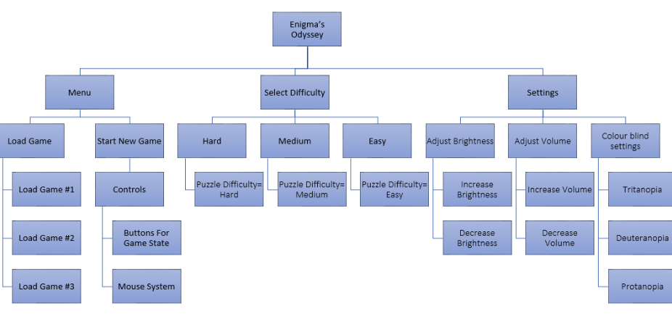

Menu:

This will consist of two options- Load Game which will allow you to load multiple saves up to a maximum of three saves. The second option is Start New Game which will then give you an option to customize the controls including what you would like to move and how you are able to use your mouse. Then begins a new game.

Select Difficulty:

This will consist of 3 options- Hard which will set the puzzle difficulty to hard, giving you less time to solve the puzzle with the aim to make it more difficult to solve, this difficulty is designed for more advanced puzzle solvers and for those who have more experience with this style of games. The second option is medium which is designed for intermediate players who have a sense of what they are doing but also want to enjoy the game while also having a slight challenge. Finally, the last option is easy which is designed for novices so that they can take as much time as they need.

Settings:

When the game is open, players will have an option to open settings to adjust their controls including brightness which allows them to increase or decrease it, their volume and colour blind settings, they can choose between three common types of colour-blindness which adds a filter over the game allowing the player to have a more enjoyable experience with the game.

### Thinking Logically

When designing the game, thinking logically involves arranging puzzles and challenges in a clear and understandable way. This includes creating puzzles with straightforward goals and solutions that players can figure out through observation and reasoning. Additionally, logical thinking influences how the game environments are laid out, making sure that everything fits together logically and that players can progress naturally. By applying logical principles to game design, like keeping things consistent.

### Thinking Concurrently

When designing the game, there will be inputs that will keep reappearing and that I will have to use recursion for such as:

1.Puzzle-solving: Recursive algorithms can be used to generate puzzles within the game, where solutions rely on breaking down larger problems into smaller, more manageable ones.

2. Character movement: Recursion can simulate complex movement patterns for non-player characters

3. Object interactions: Recursion can control interactions between in-game objects, such as unlocking doors or triggering mechanisms, by recursively checking for conditions and executing corresponding actions.

### Conclusion

The previous sub-headings explain how my problem can be solved though the use of computational thinking. The methods I addressed in my previous sub-headings can help to give my solution a structure which will make it easier to solve, making it suited to a computer program. If the problem is solved, then there will be a successful game where users can solve puzzles in the different ancient eras, where they get to move and experience different lifestyles in multiple civilisations. This is aimed to be a type of entertainment to my players.

## Success Criteria

|  |  |  |
| --- | --- | --- |
| Number | Description | Justification |
| 1. | A splash screen on the opening of the game. | To warn users about stuff like Epilepsy, Age rating, or that the game is completely fictional. Also to allow the game to fully load while the user is looking at it. |
| 2. | Functional moving forward with “W” key | The movement of the characters in Enigma’s Odyssey should be Functional and there should be a separate animation for each direction the character moves for the user to distinguish between each direction their character is moving |
| 3. | Functional moving left with “A” key |
| 4. | Functional moving right with “D” key |
| 5. | Functional moving downwards with “S” key |
| 6. | Pause Menu | The Menus and pause menu should fully work and take you to the correct screen depending on which button the user interacts with. |
| 7. | Settings button on Menu | There will be a settings button that will allow people to change and modify parts of their game so that the user can enjoy the game more as it is to the users liking |
| 8. | Resume button on Menu | If the user cannot resume their game after pausing, then a pause menu is pointless as it prevents the user from being able to carry it on. |
| 9. | Save button on Menu | Allowing users to save their progress makes it more enjoyable as they can come back to the game later and carry on from where they left and not have to restart their progress. |
| 10 | Quit button on Menu | Allow people to go back to menu so they can leave and come back to it later |
| 11 | Visual Filters | There will be a colour-blind filter for three of the most common types of colour blindness that will go over the screen to make the game more inclusive to those who are colourblind. |
| 12 | Brightness | The user will have an option to change these to improve their overall experience of the game. |
| 13 | Volume controls. | The user will have an option to change these to improve their overall experience of the game. |
| 14 | Functional puzzles | Without the puzzles the game would be unplayable so I will spend most of my time adding a variety of diverse types of puzzles. |
| 15 | Interactive characters and environment | The environment will work with the puzzle to make the game more enjoyable and there will always be NPC’s nearby to help the user if they are stuck or need help. |
| 16 | Difficulty choice | The user can choose the difficulty of the game to make it more enjoyable for inexperienced players. |
| 17 | Load games or new games | The user will be able to carry on from where they left at, if they save their progress, to prevent players having to replay the entire game up to the point they left it at. |
| 18 | Save and Quit | The user will be given an option to save before they quit in case they would like to come back to where they left off. |
| 19 | Timer popup | There will be a Timer that pops up when a puzzle begins if the necessary difficulty has been selected. |
| 20 | Victory Screen | Once the user is finished, a screen will pop up congratulating them on completing the game and thanking them for playing the game. |
| 21 | Multiple levels | There will be multiple levels that are attached and a popup will show when you cross into the next level |
| 22 | Keyboard Inputs | There will be other keyboard inputs |
| 23 | Mouse Inputs | There will be interactive inputs with the mouse. |

## Hardware and Software requirements:

### Hardware Requirements:

|  |  |
| --- | --- |
| Monitor | Requires a 320x240 bit resolution to be able to display visuals from the game |
| Mouse | Mouse to interact with objects and characters in the game |
| Keyboard | Keys to move the character and traverse through puzzles. |
| 100Mb secondary storage | Requires 100Mb of secondary storage to store game saves and to make sure progress is not lost |
| 1-2Gb RAM | High amount of RAM to store objects and run the code quicky. |
| 40 Hz Processing speed | To be able to run the game at optimal speed, it will not require a fast processor. |
| Controller | Some people prefer to use a controller so there will be an option to switch between them |
| 16-bit sound card | There will be a sound card to output the games audio such as movement and music |

### Software Requirements:

|  |  |
| --- | --- |
| PyGame engine | Required to write the code for my game and the game will be run inside of the engine. |
| Code Libraries | Libraries will be imported to make my coding quicker and reduce the time spent, as I can just reference it and use it. |
| Windows 10 or later | I will require windows 10 or later to run my game. |
| Python | I will be using python as my main game. |

### Time Limitations

One feature I would want to add is multiplayer and allow 2 players to play on a single keyboard, and to then solve puzzles and adventure together, but my time restrictions on the NEA prevent me from being able to do so, as it would take too long to code a multiplayer mode, making it a time restriction for me.

I will also need to learn a lot about python as I will need a better skillset and understanding of the language to be able to write my NEA. This will take up a lot of time and cause my coded solution to stretch over a longer period as I will need to spend a lot of time learning how to code more advanced things.

I would also like to allow users to re-bind their buttons as it would make the game a lot more enjoyable. However, it will take a lot of work to allow users to bind any button to anything, as I would have to make an algorithm that would: take an input un-bind a button to a control and then re-bind it to the input, then return and save it as a variable, which is possible but extremely time consuming.

### Hardware Limitations

Having a large number of objects on the screen is something I'd like; however, it would require too much processing power which would remove the point of my game, which was to be a simple puzzle game that could be run on any device.

Having other mice so that multiple people can play on the same device, however this would be a hardware limitation as I do not have access to a second mouse, this is also one of my time limitations because it would take so long to make a multiplayer mode.

## Game Research From Other Similar Games

### Research into Brawlhalla:

Unlike the game, the character will be stuck in one point of the screen and the only thing moving will be the background.

I want to have my characters in the same style as this, an arcade indie style.

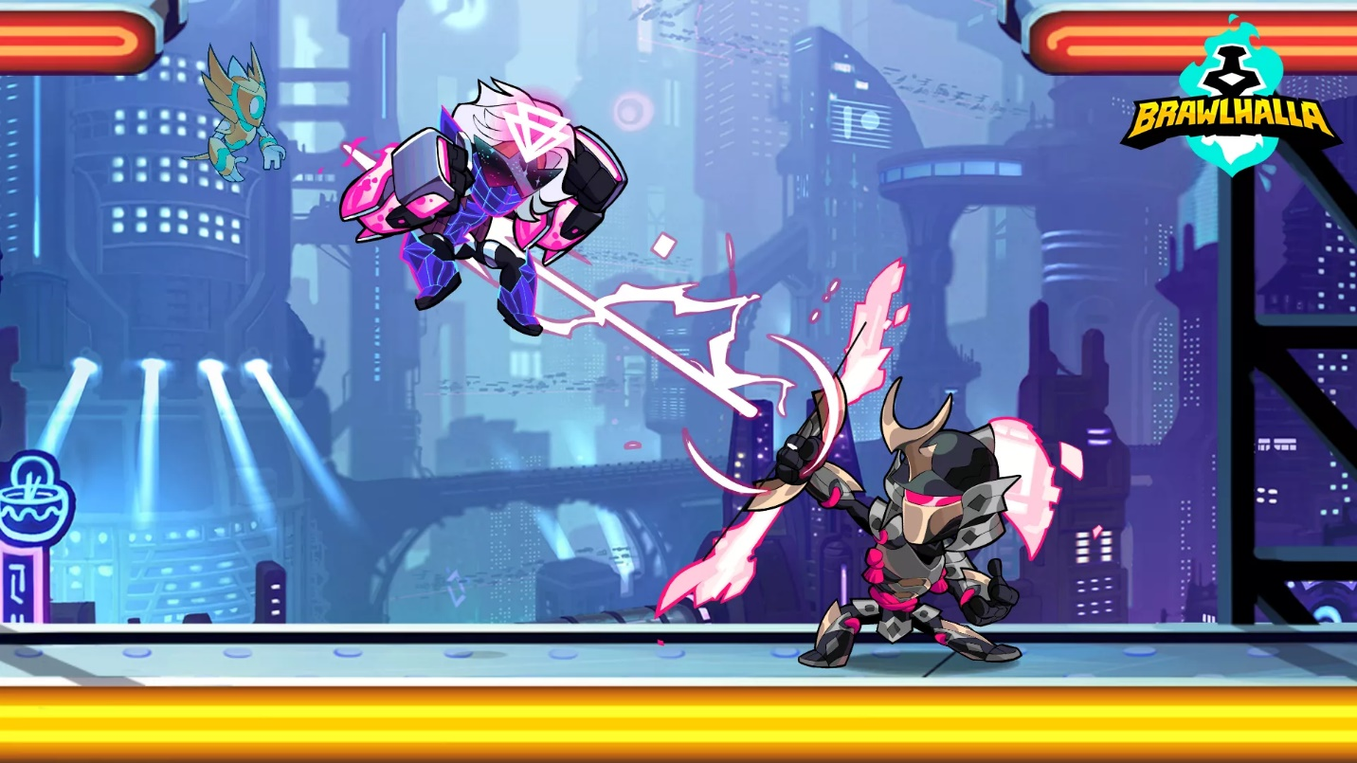

The character will move on a platform that goes on to the end.

There will be a similar background, in a sense that it matches the theme of the level, in this specific one it is a very futuristic and dystopian theme and the background will match it.

I plan on making my menus UI similar to this, having my interactable buttons in a ordered column

There will be a settings option and a help option in the top of the screen if it is needed.

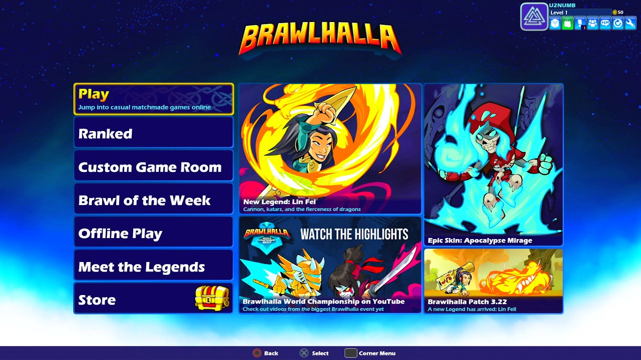

I will have a title of Enigma’s Odyssey centred in the top of my menu screen.

### Research Into Different Puzzle Solving Games

I will change the theme of the game, by adding cultural things from Ancient Egyptian times such as a sphinx or artifacts.

This is the type of puzzle I plan on adding to my game

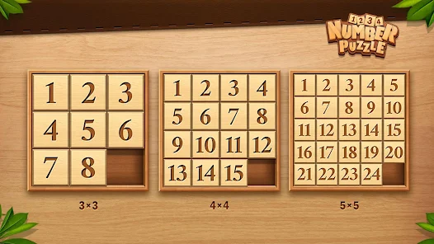

Each difficulty will have a different sized puzzle, easy will be 3x3, medium will be 4x4, and hard will be 5x5.

This again is another puzzle I plan on adding to my game as it seems very interesting and enjoyable

I will again also be changing the theme, by adding things to the background, and changing the wooden material to a sandy brick

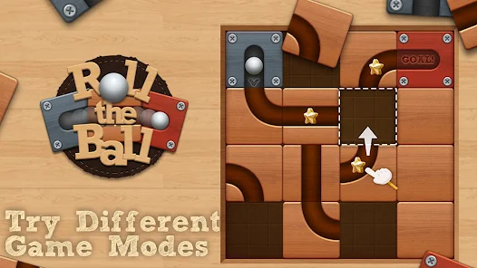

There will be different puzzles again for each difficulty, the harder the difficulty the longer it should take as it will be a larger and more complex puzzle

### Research Into My Theme

This is the theme of the background that I aim to have in each of my puzzles and my side sliding part

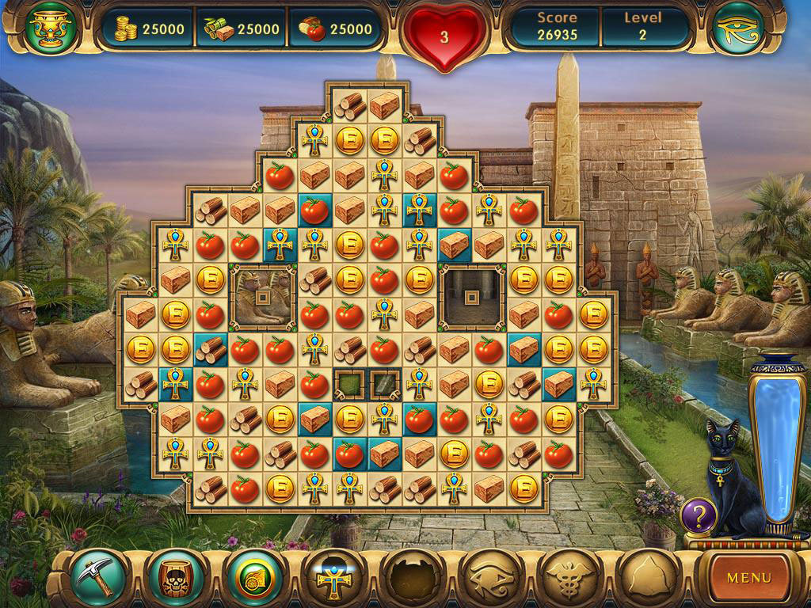

The background, theme and shape is exactly what I will be going for, as it achieves my goal of matching it to ancient times.

These are the types of artifacts and subtle things that I would like to reference as I believe it will add more realism and authenticity to my game.

## Research Into Terraria

When the character loads into my game, I will display a large Title of Enigma’s Odyssey.

# Terraria

This texture and retro style are what I will be including in my game. My background will consist of blocky rough terrains and pyramids to replicate Ancient Egypt

# 

My sprites will be very basic as shown in terraria.

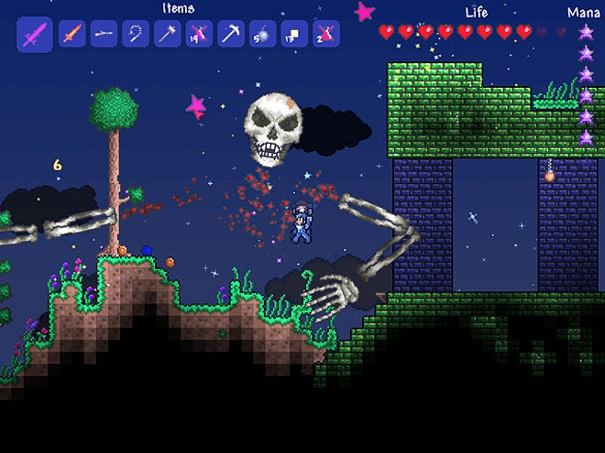

In addition to the problem solving, I will also add a rough terrain going up and down, so that the player has to work their way around obstacles to make it slightly more difficult. This will be the same no matter the difficulty.

The world will go from light to dark every few minutes to simulate daylight and nighttime.

# Design

## Systems Diagram

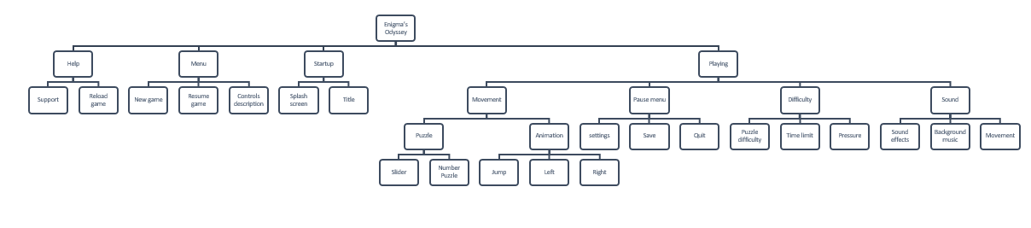

Why am I using this approach as a solution to my problem?

I will be using a hierarchy/ top-down solution as it gives me an idea of what I must do to create a functional game. By breaking down each problem into smaller sub-problems using decomposition, it will allow me to approach each problem easily as I would've already broken it down into easy to approach parts. This will also allow see where I can link certain parts of my game to other sections such as sound and audio settings, as they can be adjusted from two different places, the title screen, and the in-game pause menu. By doing this I will be able to re-use different parts of my code in multiple areas, making the process more efficient.

## Explanation of Each Module

**Help:**

**Support:**

Holds answers to common questions and the solutions to any bugs that could be affecting the users gameplay.

**Reload Game:**

Allows the user to restart the game if there is something not running properly and there isnt a solution to the problem.

**Menu:**

**New Game:**

The New game allows the player to create a new save and begin a new world

**Resume Game:**

Allows the user to pick up where they left off instead of having to re-do the entire game to get back to where they left off, making the game more convenient.

**Controls Description:**

Small tab that can be opened in the menu to guide the user on how to use each button and what each key is bound to.

**Startup:**

**Splash Screen:**

I will add a splash screen with music at the start to set the theme of the game and to attract players to the visuals of my game.

**Title:**

There will be a title that comes up displaying Enigma’s Odyssey.

**Playing:**

**Movement:**

The game and the character will have interactive moving parts.

**Puzzle:**

**Slider:**

One of the puzzles will have a moving slider to move parts around the screen.

**Number Puzzle:**

One of the puzzles will include moving numbers around the screen which will have sliders.

**Animation:**

There will be an animation for every movement.

**Jump:**

The sprites will have an animation where they can jump vertically, to get over potential obstacles

**Left:**

The sprite will have an animation when moving towards the left.

**Right:**

The sprite will have an animation when moving towards the right.

**Pause Menu:**

**Settings:**

There will be a settings option which will allow you to increase and decrease volume, increase and decrease the brightness, and to add colourblind filters.

**Save:**

There will be an option to save your progress so that you can open it back up to where you left.

**Quit:**

Allow user to return to menu after saving their progress.

**Difficulty:**

Allow users who want a challenge or

**Puzzle Difficulty:**

Change the actual puzzle to something more difficult depending on the difficulty setting set by the user.

**Time Limit:**

The amount of time given is dependent on the difficulty set by the user.

**Pressure:**

There will be screen shake if the time goes lower and the amount of it will change dependent on the difficulty settings

**Sound:**

There will be various sounds throughout the game

**Sound effects:**

There will be sound effects while traversing through each puzzle and through the menu

**Background Music:**

There will be a different background music for each world theme to enhance the gameplay.

**Movement:**

The movement while create a sound after each step or while jumping and landing from a jump.

## Usability Features

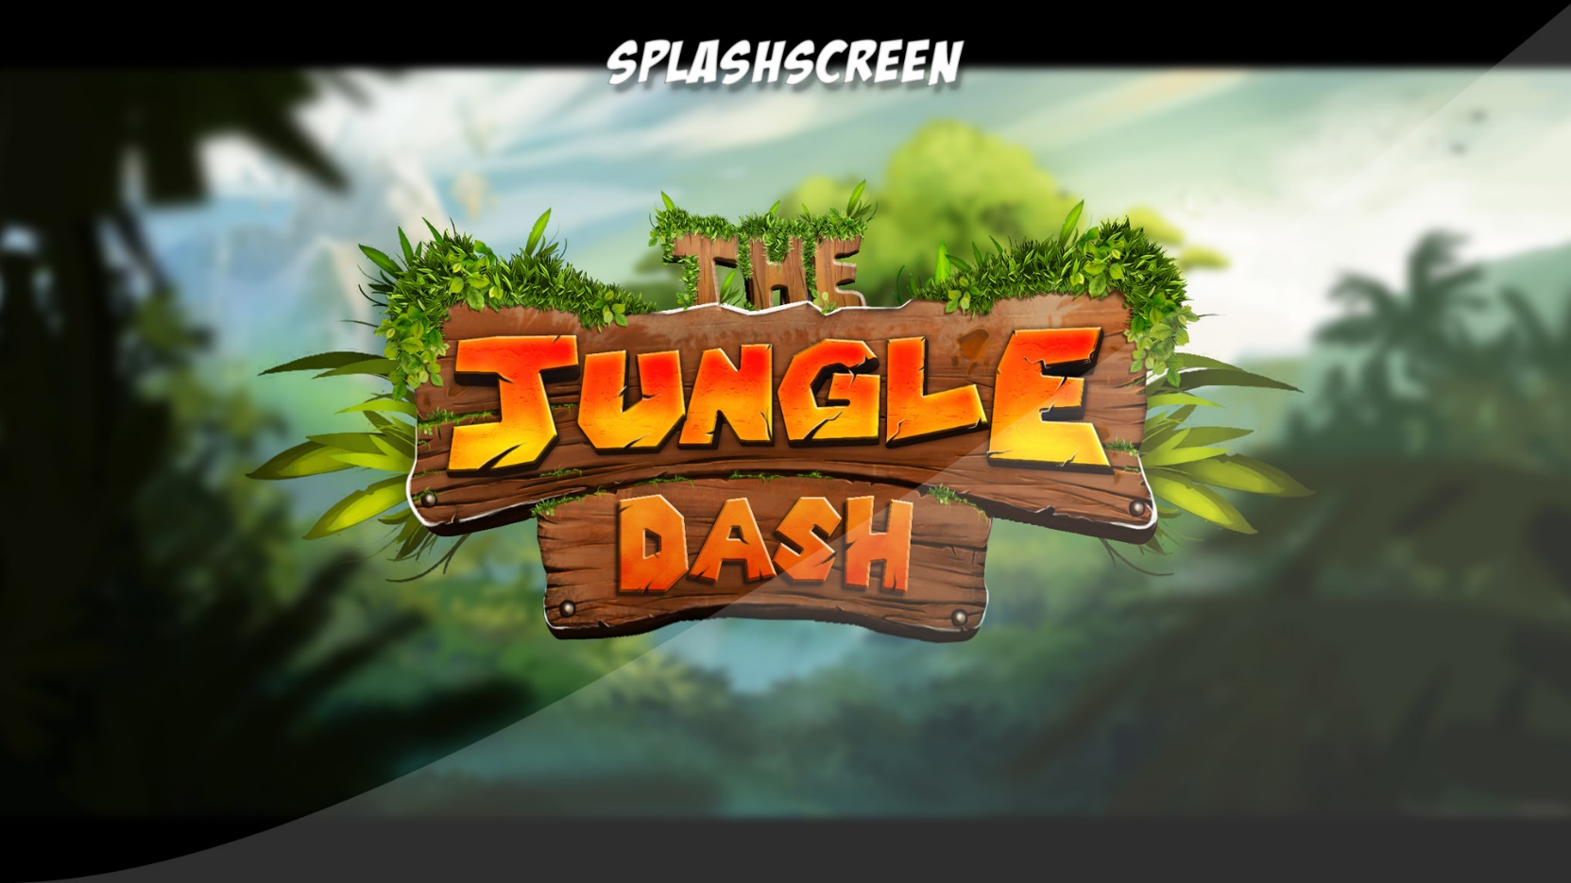

Options button for the user to change the different settings of the game

All buttons clearly laid out and in a big font so that the user knows what is available and what options they have.

Quit button to make it easier to quit rather than having to X out.

Play button for the user to easily know how to begin the game.

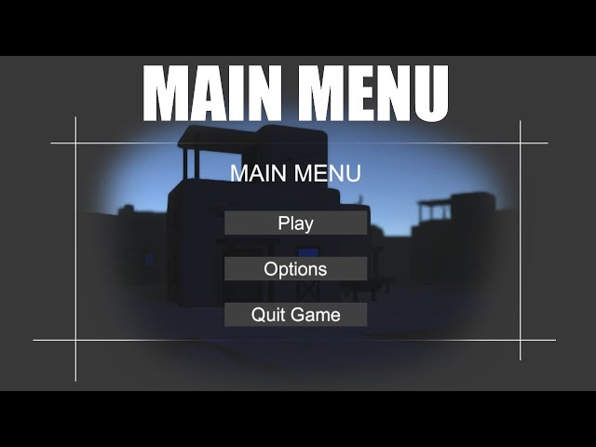

All buttons clearly laid out and in a big font so that the user knows what is available and what options they have.

Title clearly laid out so that the user knows they have the settings tab opened up.

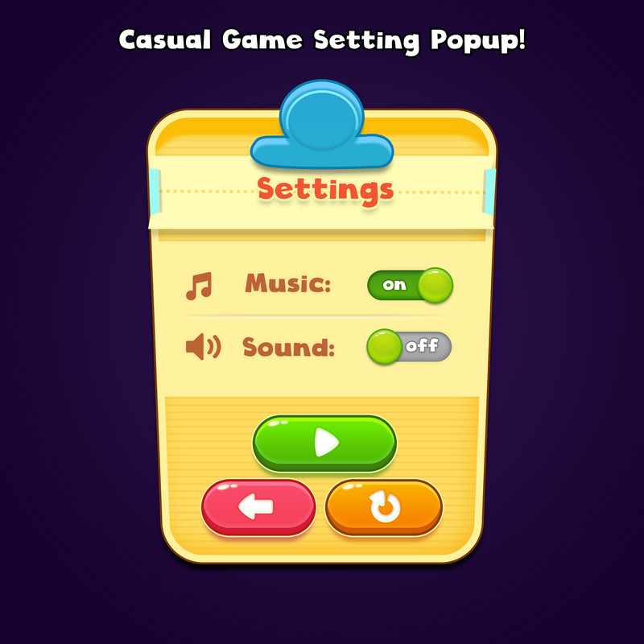

Title clearly laid out so that the user knows they are on the end game screen.

All data from their game displayed on the end game screen so that they can see their stats from the run they just had.

Button clearly indicating for the user to return to menu, so that they know what to do next.

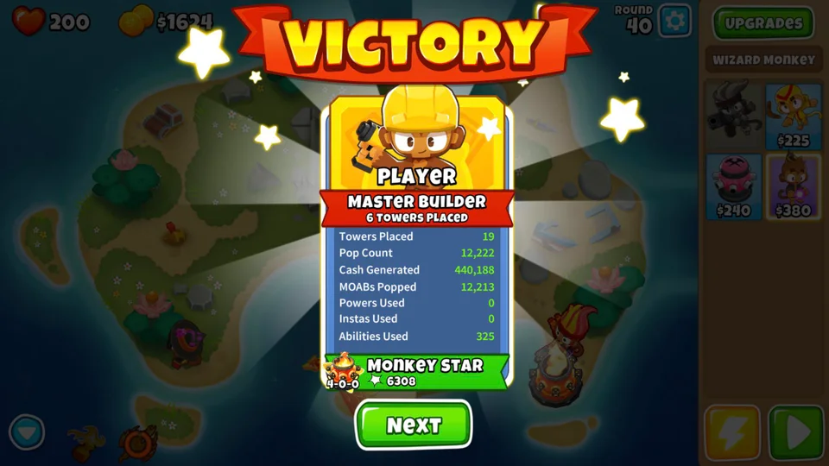

Each part of puzzle clearly laid out for user to see

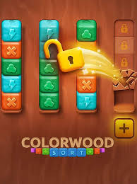

A background in a game enhances visual depth, helps guide the player's focus, and can provide context and atmosphere, improving the overall usability by making navigation and objectives clearer.

The character will have different images looping around at once to give the illusion that the character is moving

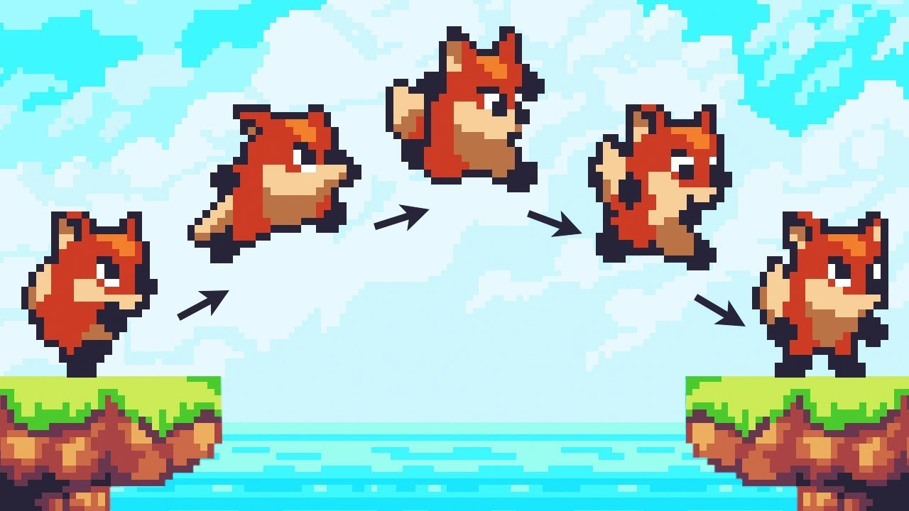

Different levels in a game keep things interesting, make the game harder as you progress, and help players feel like they’re getting better.

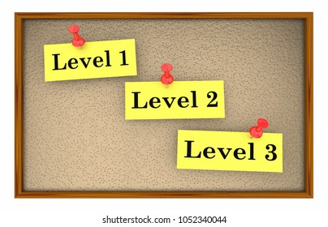

## Classes

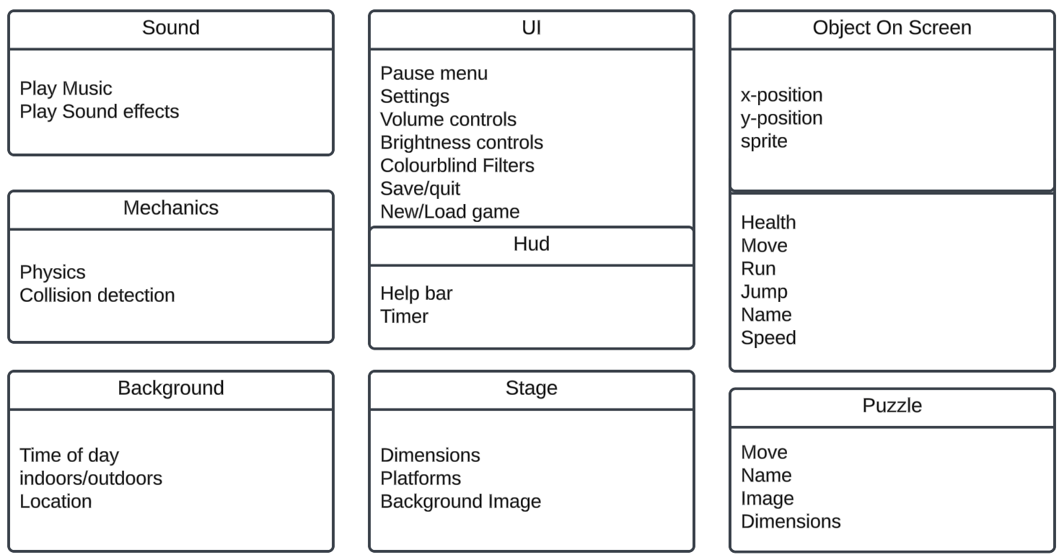

## Algorithms

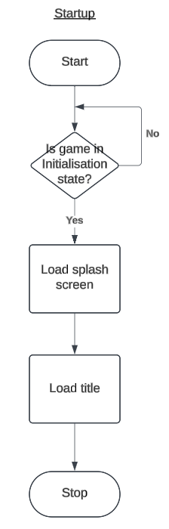

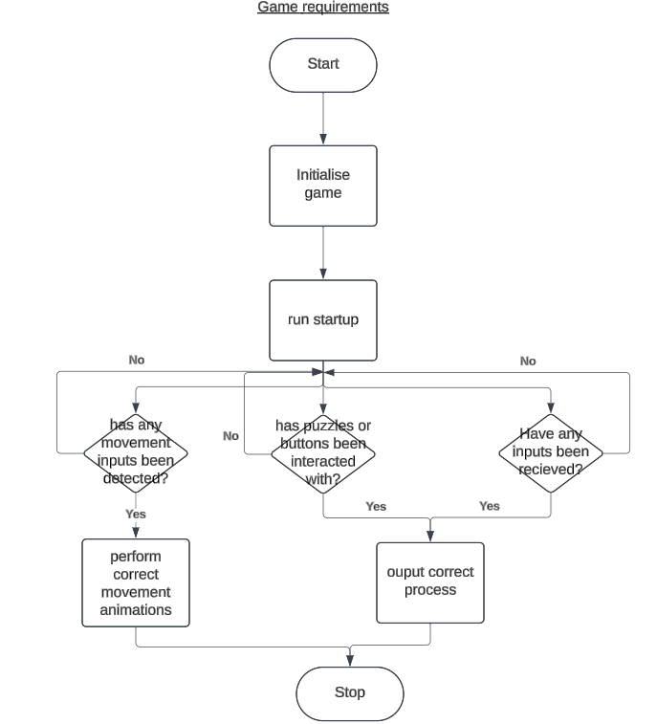

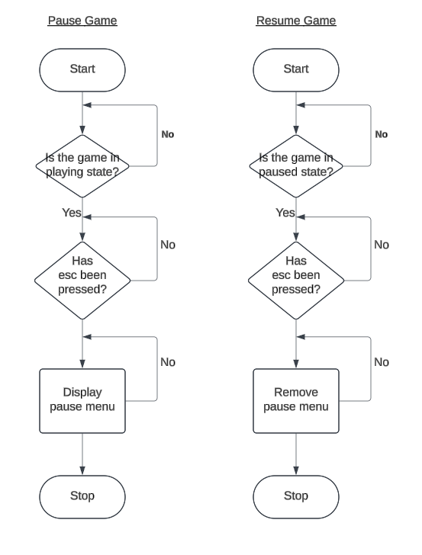

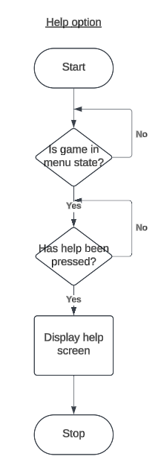

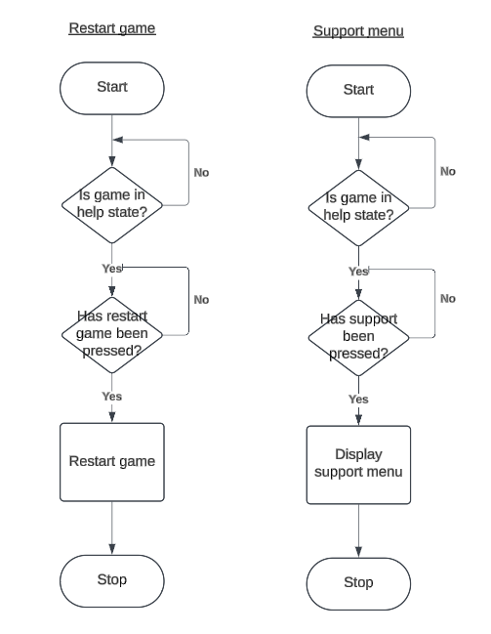

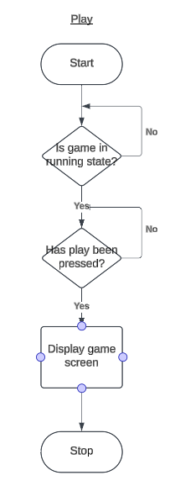

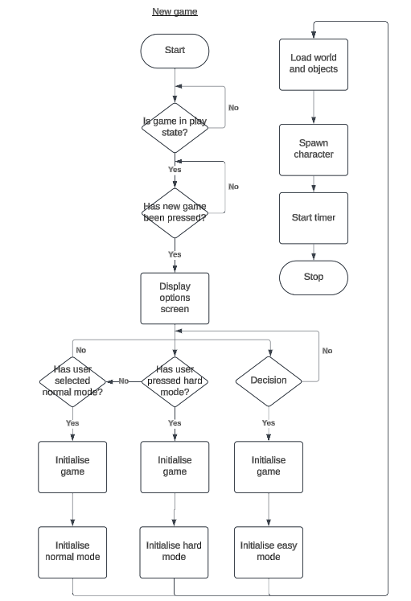

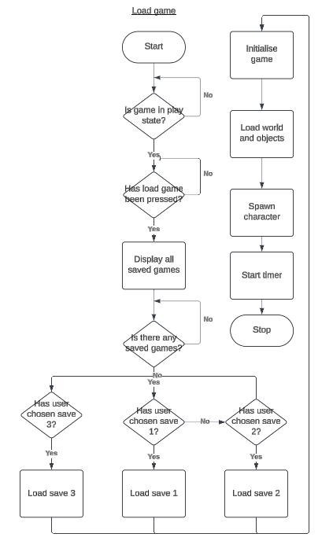

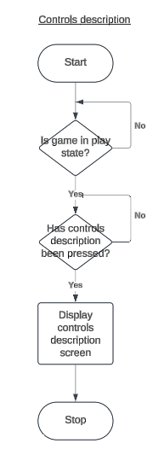

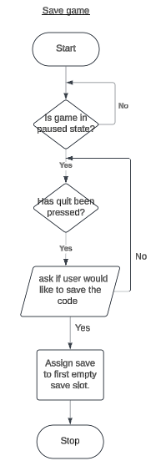

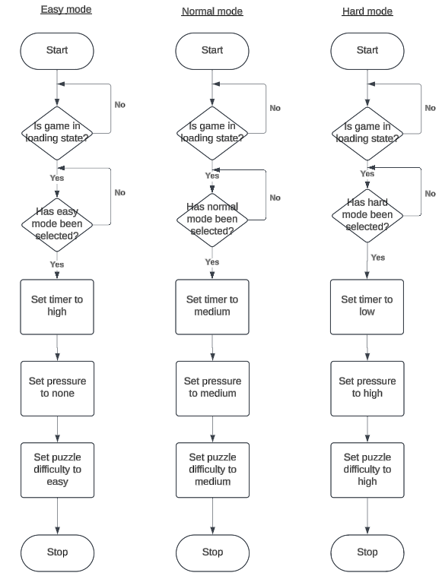

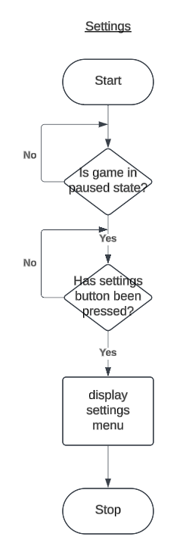

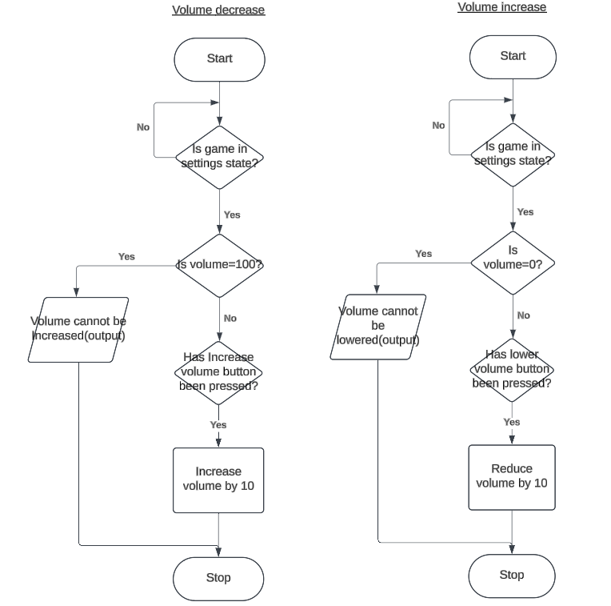

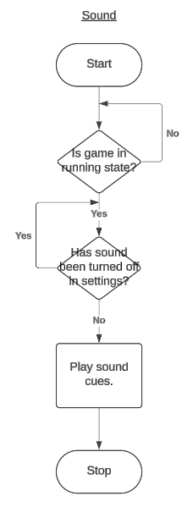

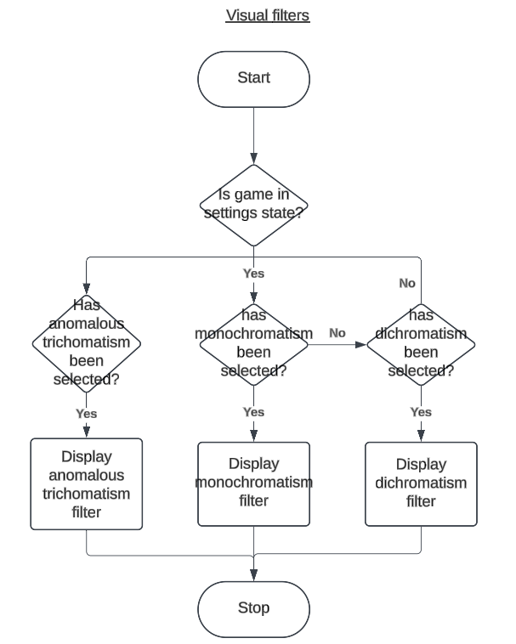

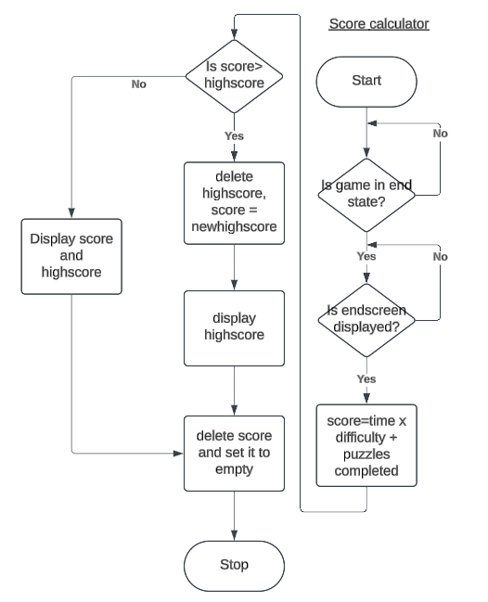

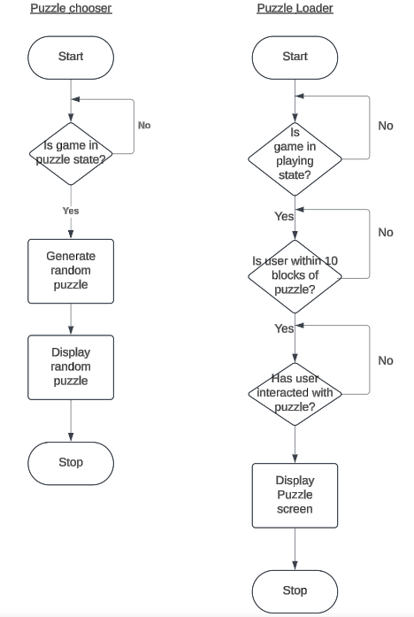

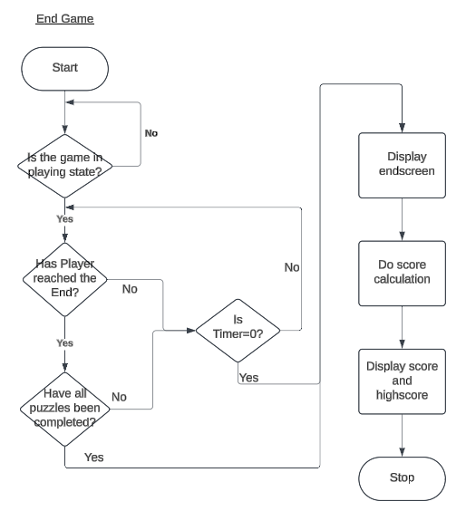

## Key Data Structures and Variables

|  |  |  |  |  |
| --- | --- | --- | --- | --- |
| Method | Name | Data Type | Explanation (What it does) | Justification (Why you need it) |
| **All Menus** |  |  |  |  |
| Procedure | LoadingScreen | N/A | Loads the main title and splash screen. | This is the main introduction of the game and will set the atmosphere of the game. |
| Game State | MainMenu | N/A | Displays buttons for the user to traverse through at the beginning of the game. | This allows the user to play the game and get support if they need help. |
| GameState | PauseMenu | N/A | Stops current game being played and lets user exit the game or access SettingsMenu. | To allow user to exit and save the game or to take a break. |
| Game State | SettingsMenu | N/A | Displays buttons for the user to change the settings. | Allow user to display filters and change volume. |
| **Game Mode** |  |  |  |  |
| Variable | Hard | String | Increases difficulty for the user. | Some users may be more advanced at puzzle solving and want a challenge. |
| Variable | Medium | String | Maintains difficulty for the user. | Some users may prefer a more casual experience rather than easy or hard. |
| Variable | Easy | String | Reduces difficulty for the user. | Some new players may want to have a better experience with the game, so they opt for an easier mode to understand it before progressing. |
| **Sounds** |  |  |  |  |
| Procedure | GameSoundEffect | MP3 | Plays game sound effects when required. | Make the game more entertaining by having objects make sounds when you interact with it. |
| Procedure | GameMusic | MP3 | Plays game music when the game begins to load until StageLoad is true. | Having game music as it is being loaded up allows users to enter the right atmosphere before playing. |
| Variable | MenuSoundEffect | MP3 | Plays sound effect when user presses a button in any menu. | Menu sound effects are useful as a confirmation that the user clicked on the button. |
| **Gameplay** |  |  |  |  |
| Procedure + Variable | StageLoad | N/A | Loads the stage for the sprite, loads any obstacles/puzzles and background. | Required to load the obstacles, puzzles, stage and background which are essential to the game. |
| Variable | ControllableSprite | jpg | Sprite that can be controlled by user. | The sprite must be able to be controlled otherwise it cannot move which defeats the entire purpose of the game. |
| Procedure | PuzzleLoad | N/A | Loads puzzles when interacted with. | Having puzzles load when loading up the game rather than when interacted with will be too heavy on the RAM, especially since I specified that it will not be a demanding game, this is a method of optimisation to make it easier to run for more generic PC’s. |
| Variable | TimerSize | String | Controls and displays how much time the user is given depending on game mode. | Can change the timer between different game modes, increasing for easier game modes and vice versa for harder modes. |
| Variable | PressureType | String | Controls and displays the amount of screen shake depending on game mode and TimerSize. | Adds difficulty to the game for more advanced players by shaking the screen during a puzzle to simulate pressure. |
| Variable | ScoreCount | Integer | Keeps count of what the user has done and speed of solving each puzzle. | This makes calculating a final score much easier then retracing everything the user has done after the game has ended by just keeping track of what the user has done. |
| Procedure | PuzzleScreen | N/A | Loads the puzzle screen | The puzzle cannot be solved if the user cannot see and interact with it, making it essential to the success of the game. |
| **Movement** |  |  |  |  |
| Procedure | MoveLeft | N/A | Slightly moves the sprite to the left of the stage. | Allows the user to move the sprite across the stage |
| Procedure | MoveRight | N/A | Slightly moves the sprite to the right of the stage. | Allows the user to move the sprite across the stage |
| Procedure | MoveDown | N/A | Moves sprite down if they are in the air or above a breakable obstacle. | Allows the user to move the sprite across the stage |
| Procedure | MoveUp | N/A | Makes sprite jump vertically. | Allows the user to move the sprite across the stage |
| Procedure | PuzzleTraversal | N/A | Moves puzzle piece around when PuzzleScreen is true. | Allows user to traverse puzzle pieces around, to complete it. |
| **PostGame** |  |  |  |  |
| Procedure | ScoreCalculation | N/A | Puts necessary variables into formula to calculate FinalScore. | Calculates the score of the entire run of the game to create a competition between players and encoruage retrys and increasing the difficulty to improve their score which is essential to keeping users playing the game more often. |
| Variable | FinalScore |  | Loads FinalScore onto endscreen. | Allows users to see their final score after the run is over. |
| Procedure | LoadingEndscreen | N/A | Loads endscreen once game is completed. | Thanks players for fully completing the game. |
| Game State | EndGame | N/A | Displays button to take user back to MainMenu | Gives users the option to go back to menu and restart the game |

## Test Data

**Splash Screen**

Valid Data- Left Mouse Button

Invalid Data- “A” “2” “T”

**Play Button**

Valid Data- Left Mouse Button

Invalid Data- “S” “5” “3”

**Options Button**

Valid Data- Left Mouse Button

Invalid Data- “A” “2” “T”

**Settings Sliders**

Valid Data- Left Mouse Button

Invalid Data- “P” “8” “4”

**Movement**

Valid Data- “D” “A” “Space Bar”

Invalid Data- “A” “2” “T”

**Puzzle Interaction**

Valid Data- Left Mouse Button

Invalid Data- “P” “8” “4”

**Camera Switch**

Valid Data- “E"

Invalid Data- “S” “5” “3”

**Puzzle Shuffle**

Valid Data- “R”

Invalid Data- “P” “8” “4”

**Finish Game**

Valid Data- Left Mouse Button

Invalid Data- “P” “8” “4”

**Back To Menu**

Valid Data- Left Mouse Button

Invalid Data- “O” “D” “L”

## Acceptance testing

|  |  |  |
| --- | --- | --- |
| Requirements | Input | Expected Outcome |
| Main menu should load on game start | Start the game | The main menu appears with Play, Options, and Quit buttons |
| Play button should load the puzzle game | Click "Play" | The puzzle scene loads with the correct settings |
| Quit button should close the game | Click "Quit" | The game closes (works in a built version) |
| Options button should open settings menu | Click "Options" | The settings menu appears with volume, brightness, and difficulty choices |
| Volume slider should adjust game audio | Move the volume slider | Game audio adjusts accordingly |
| Brightness slider should adjust screen brightness | Move the brightness slider | Brightness changes dynamically |
| Selecting difficulty updates puzzle size | Choose Easy, Medium, or Hard | The puzzle adjusts to **3×3, 4×4, or 5×5** respectively |
| Selected difficulty works between scenes | Choose difficulty and press Play | The selected difficulty applies to the puzzle game |
| Puzzle pieces should move when clicked | Click on a movable puzzle piece | The clicked piece swaps with the empty space if the move is valid |
| Puzzle should shuffle on start | Load the game scene | Puzzle pieces appear in a random order |
| Puzzle should be solvable using the correct sequence of moves | Arrange pieces in numerical order (or correct positions) | "Puzzle Complete!" message is displayed |
| Track and display number of moves made | Move a piece | Move count increases and updates on the UI |
| Move count resets after shuffling | Press **R** to reshuffle | Move count resets to 0 |
| Reduce high score with every move | Move a piece | High score decreases by 10 |
| Reduce high score by 5000 when reshuffling | Press **R** to reshuffle | High score decreases by 5000 |
| High score decreases over time | Wait 1 minute | High score decreases by 1000 |
| Display high score on UI | Game starts | High score is displayed in the UI text box |
| Difficulty selection persists between scenes | Select difficulty and load game scene | The puzzle size matches the selected difficulty |
| GameManager can access HighScore script | Game starts | HighScore script is correctly referenced and modifies score when required |
| Game should properly check for puzzle completion | Arrange pieces in the correct order | The game detects when all pieces are in the correct position and marks the puzzle as complete |
| UI text should update in real time | Change high score or move count | |  | | --- | | UI text box updates in real time | |
| Settings menu should have a back button | Click "Back" in options | The button returns to the main menu |
| Finish game button switches to end scene | Click “Finish Game” in game scene | The button switches to the end game scene. |
| End game button switches to main menu scene | Click “Back to menu” in end game scene | The button returns to the main menu |

# Developing the Coded Solution

## Choosing the correct Game Lab

At the start of my project, I chose to avoid Unity because I wasn’t familiar with the C# programming language. Although Unity is widely known for its powerful tools and features, I felt more confident using Python since I was already familiar with it. When starting with it, I decided to begin by creating a menu screen, however every time I attempted to run it, an error message would appear saying “Module not found”.

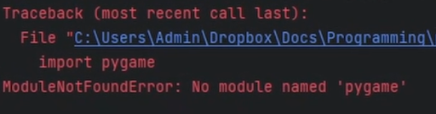

I decided to research and ask around about it, but everything would give the same solution which did not work. So, after multiple hours of trying to find a solution, I decided to switch over to unity as I had only just begun coding on Pygame and I could easily start again on Unity.

## Learning C#

Before I could start developing my game on Unity, I first had to learn the C# programming language. To do this, I first started by watching tutorials on YouTube and then switched to a website for tutorials on different things, I used W3 Schools for this because of its simplicity.

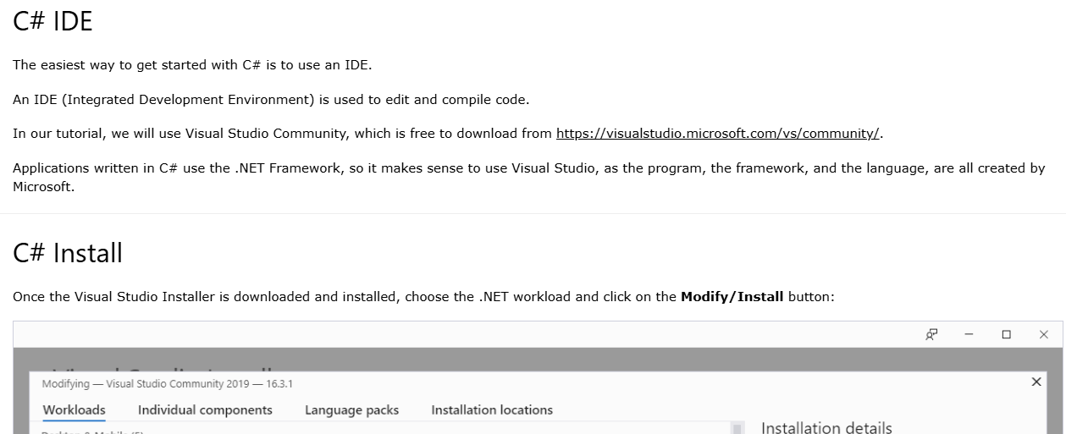

I used a mixture of this and YouTube until my understanding of the language was up to a standard that was good enough for me to begin developing my game.

## Learning the Game Lab Environment

I also started learning the environment in unity so that I could save time later not having to watch a tutorial every time I wanted to do anything. I used “The Unity Tutorial for Complete Beginners” by the game makers toolkit. <https://www.youtube.com/watch?v=XtQMytORBmM>

After learning about Unity’s environment and the language C#, I was ready to begin coding and start the development of my game.

## Searching and looking for Sprites

I had to import some sprites before beginning to use as my character and as building blocks. I used itch.io to find my game sprites. After finding the ones I wanted to use, I had an issue with importing them because they were not in the correct format. They had to be in PNG format, and they were not. 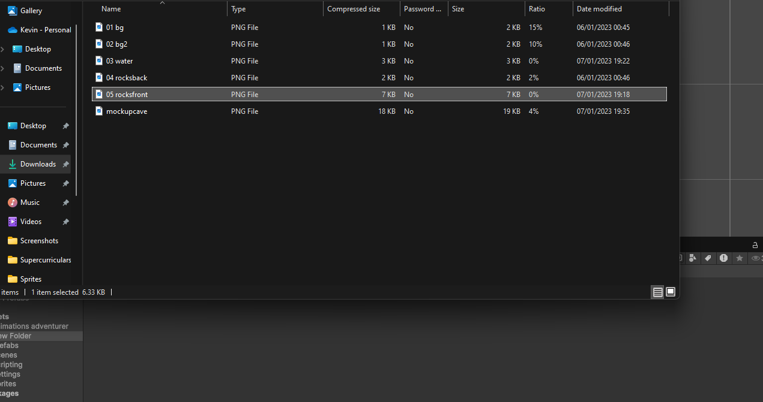

I decided to search online for a website to turn them into PNG form so that I could import them, I ended up using online-convert.com and after that Unity worked completely fine when importing my sprites.

## Creating a Platform and Using My Sprite

I first began by creating a platform and creating my first character with my imported sprites to test all the movement features that I planned to add. I then proceeded to add a rigid body to my character and added physics to it so that it could move correctly. I then added colliders as the sprite would keep falling through the platform every time I ran the game.

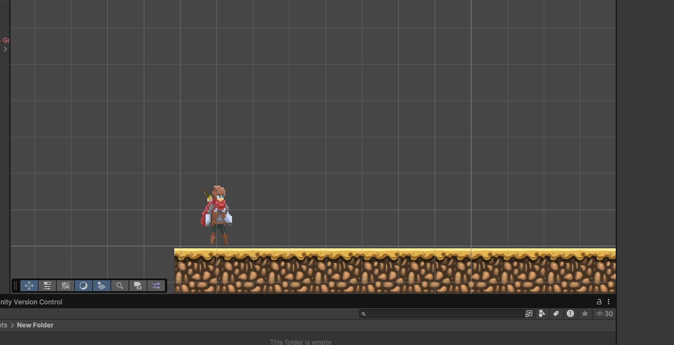

## Moving Left and Right

Before adding any features to my game, I wrote a script to allow my sprite to move left and right so that the user could navigate through the obstacle course that I planned to add, depending on input from a keyboard. It does this by taking an input from the keyboard and setting the left arrow or “A” as –1, no input as 0 and right arrow or “D” as 1. If the input is –1, the sprite will move left, if it is 1 then it will move right, and if the input is 0 it will stay stationary. I also added a speed control button to be able to choose how fast the sprite will move.

Testing input data: When testing this, I had to check if the other keys could potentially cause the character to move left or right and whether D might move the character the wrong way and the same for A.





## Flipping the Character

I decided to add a feature to my previous script so that the sprite flips depending on which way it is moving, allowing the player to know which way the character is going, it was not essential but improved the look of the movement. It takes the 1, -1 input and flips the sprite depending on what the number is.

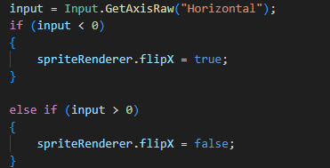

Testing input data: I had to put in numbers other than 1, 0 and –1 to make sure the game would not be affected by this, if one of my functions went wrong and put in the wrong number, I had to make sure the game would not be affected by this and would carry on as expected.

## Jumping

I added a feature that allowed my sprite to move vertically by pressing space bar so that they could navigate through the obstacle course that I was going to add after making the puzzle, however it had an issue where it would continuously jump up if you held spacebar or repeatedly pressed it.

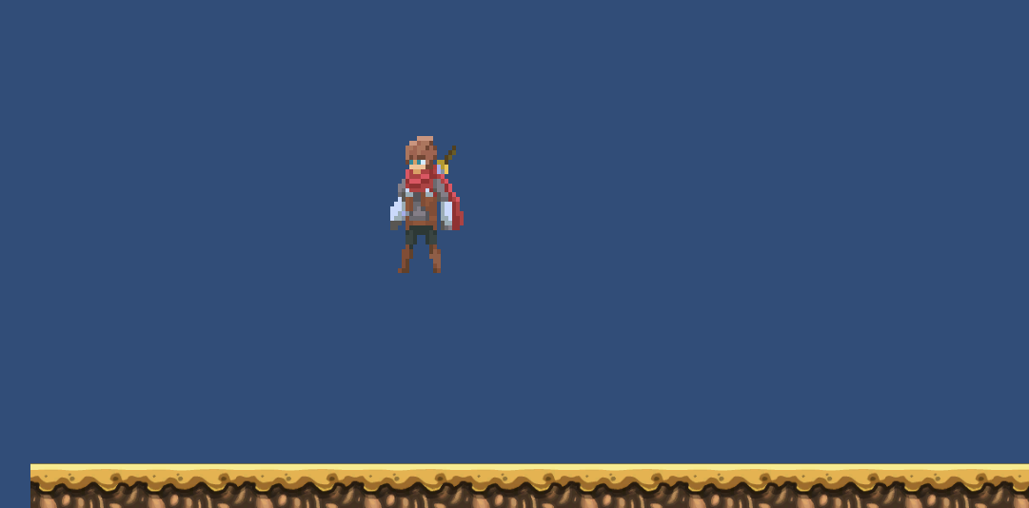

To fix this issue I added a box that was a condition for the character to jump, as the box had to be in contact with the ground for the character to jump, and I used an if statement to do this. This completely solved the issue where it would jump infinitely, however I was still not satisfied with how it would look when the character would jump even when I would change the physics and jump strength. I decided to improve the jumping by adding a timer where the character could continue going up so that the height of the jump is controlled by the user. If the user tapped space bar, it would slightly go up and the longer it was held down, the longer it would continue to rise until the user let go of space or the timer would hit 1 second.

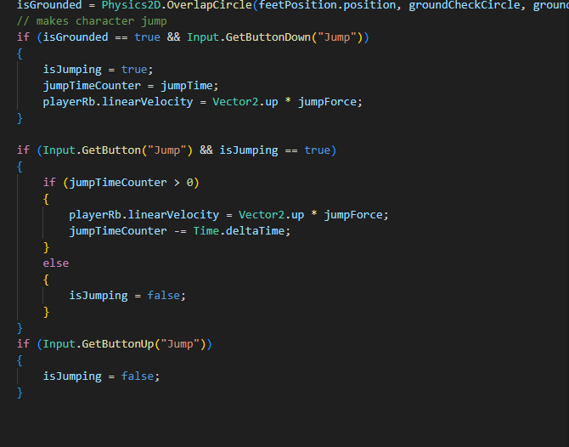

IsJumping-Variable to check if the character is jumping, jumpTimeCounter- variable to change the time you can hold down the jump for,Jump force- Variable to change the strength of the jump.

The first function is to move the character vertically if the space bar is pressed, and the final if statement is to check if the character is not jumping.

Testing input data- I had to check to make sure no other key caused the character to jump. I also had to hold the spacebar for longer than the jump time to make sure the character wouldn't keep going up and finally try and jump a second time in the air to make sure they character cannot double jump.

## Camera Movement

I wrote a script for the main camera to follow the sprite so that the user could see the characters movement. Although this was a longer route, I did this so that it would not follow the rotation of the sprite, and I did this by writing a line of code that ignores the Z axis movement so that it only follows the vertical and horizontal components of the sprite, and if I were to just use the built in camera, it would follow the rotation of the screen and it would ruin the user experience.

Testing input data- I had to test to see if the camera followed the character when using the movement keys, then i tried different inputs in the offset which did not change anything, I tried jumping and holding jump button to see if once the jump timer ends if the camera will continue to rise because the game thinks the character is still moving up.

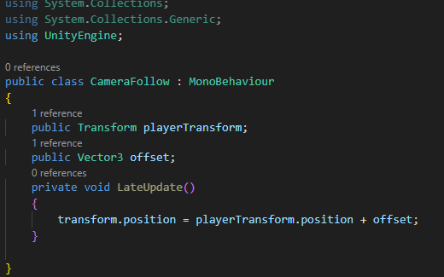

The class shown above moves the cameras position to a specific offset while also following the character.

## Creating My Puzzle

I originally wanted to create a jigsaw puzzle game however I switched it to a puzzle slider game because of time constraints. I began by creating a material and attaching the image of my choice to it.

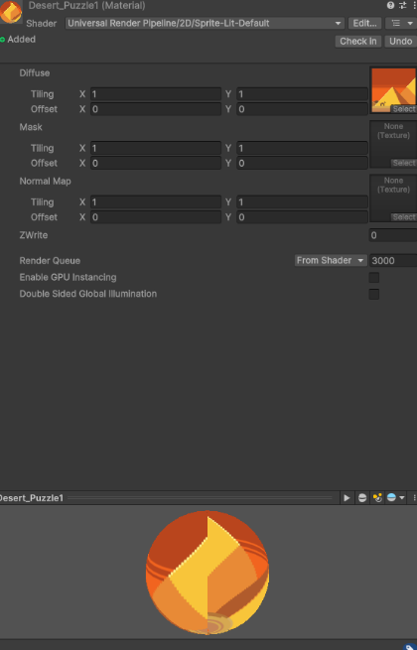

When I had first started writing it, I had an issue with displaying the screen as it would show the entire picture in each part of the puzzle. Unfortunately, I have already fixed the issue and cannot show it as I did not take a photo of it but while making the puzzle it split up completely fine, it was just the entire photo in each part that went wrong. I fixed this issue through enough debugging but now the issue was in the images showing up as very distorted and weird-looking, and again after enough testing and debugging I was able to sort this issue, and it was caused by my parameters for my UV being passed through incorrectly.

This was much harder to read because of my poor readability when writing it and lack of comments. I then decided to add comments to all my code, including my characters movement script and the script for my camera movement. I then had to add a white space for my puzzle to allow it to move around. I also made it a random movement so that it is in a different place each time, preventing the puzzle from being instantly solvable. I then went on to create a script to randomise where each part of the puzzle goes, and finally a user interface so that the user can interact with the puzzle and solve it.

Testing input data- I had to test different images/ materials to see if the puzzle displayed the puzzle correctly which worked completely fine.

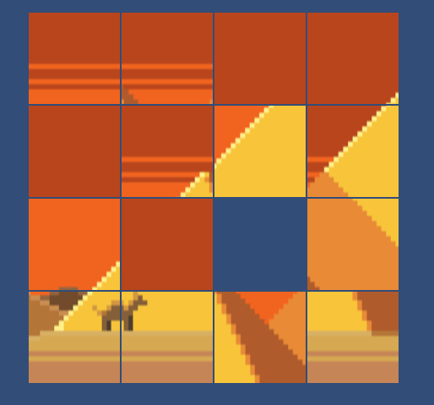

## Method for cutting up image

I originally wanted to cut it up individually and make each difficulty a separate puzzle, but it would have taken too much time so instead of doing that I thought of an easier way, where instead of this I would put the image into a material and place the material into the puzzle script, and it would split up the image into different slides depending on the puzzle. I used a function that would split up the given image into whatever I inputted into the material, into as many pieces as I wanted.

Testing input data- I tried out all the difficulty settings to check if the image cutting worked correctly, and if there was any way to ruin it, potentially by changing the settings while the program was loading, which it didn't.

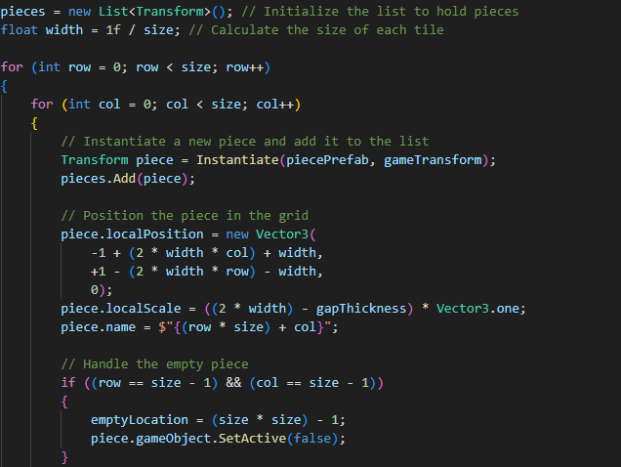

## Adding Difficulty Levels

I wanted to add different difficulty settings to make it more challenging for those with more experience and I organised it in a simple way, hard, medium and easy. Hard being a 5x5, medium being a 4x4 and easy being a 3x3. After writing the code the only thing that showed up was an empty screen

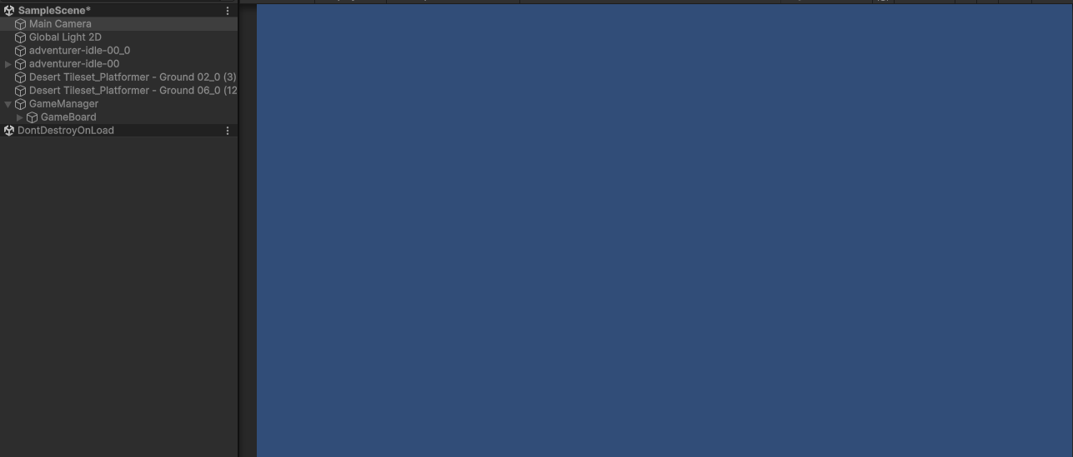

This led to me having to edit my code and it was just the offset for the camera being moved in the x-axis preventing me from being able to see the code working. I also accidentally hardcoded the difficulty values, making them unchangeable, and I fixed it by allowing the difficulty to be set dynamically through player input. I also thought it did not look too great when moving each piece, so I decided to add animations to the pieces when they move however an issue with it was that every piece of the puzzle would move to the corner when clicked on and it would not work. I spent 2 days trying to figure out a solution, but I could not create one. I ended up just removing it due to time constraints however this created another error with it zooming out on my code and making it almost invisible. This turned out to be a very small mistake where I had just forgot to delete a single line of code when reverting it back to my old one leading to the issue. I decided not to add the feature of animating it and to leave it as it is.

Testing input data- I only had to test the three difficulty settings to make sure they worked and cut up the puzzle correctly.

## Making An Object to Hold the Puzzle

I needed to create an object that could allow the character controlled by the user to interact with the puzzle because otherwise the user wouldn't be able to complete the puzzle, which would also ruin the purpose of the game. I wanted to create an interact button, which would move the characters camera to the puzzle and move it back once completed so that the user could move on to the next part of the game. I began with writing it however after completion the character was not able to interact with the button. After spending hours on fixing it, it still would not work so I decided to set a key for the camera where it switches from following the player to the co-ordinates of the puzzle.

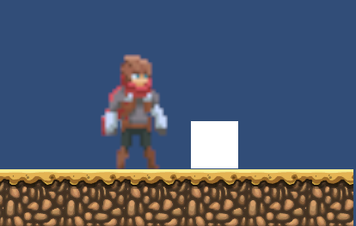

## Fixing the camera

Although originally, I intended to add a block that the user can interact with to use the puzzle, I ended up adding a block of code to my camera which when the user presses the “E” key the camera moves to a set coordinate, which I set at the puzzle, however I had a slight issue where whenever “E” was pressed it would just show the background, and this was because I had not changed the Z-axis value,

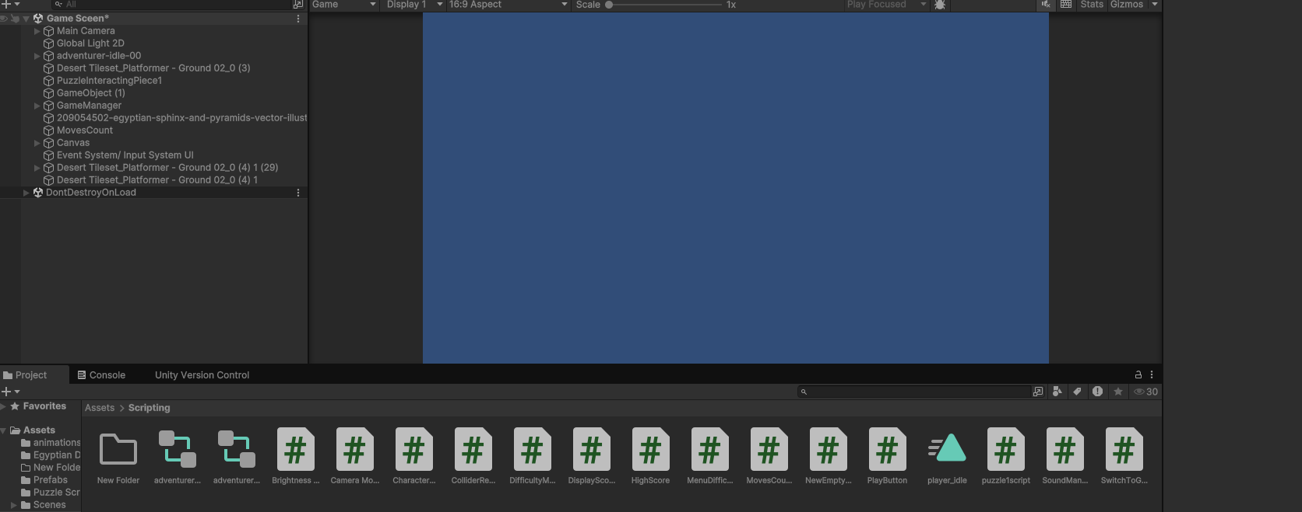

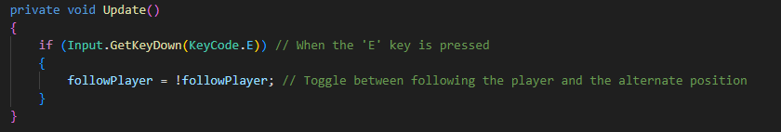

Testing input data- I also had to test the camera again to make sure that the camera moves between the character and the puzzle correctly by checking to see if changing the offset for when it is following the character will change the offset for the puzzle and hide the puzzle. I also tried to change the Z axis to see if that would change everything overall.

## Adding Features to my Puzzle

I wanted to add some more features to my puzzle, and decided to add a shuffle button that randomly shuffles the puzzle, however one issue with it was that it would move the empty space and just move the piece that it moved to into its original place. So, to fix this I messed around with the UV settings until it finally worked and set a key as R for the function, so that now whenever the user presses R, all the pieces in the puzzle shuffle randomly and continue to work as normal.

Testing input data- To test the shuffle feature, I had to try moving the blocks and shuffling at the same time to see if the program would crash, I also had to test if the program would run as normal after shuffling.

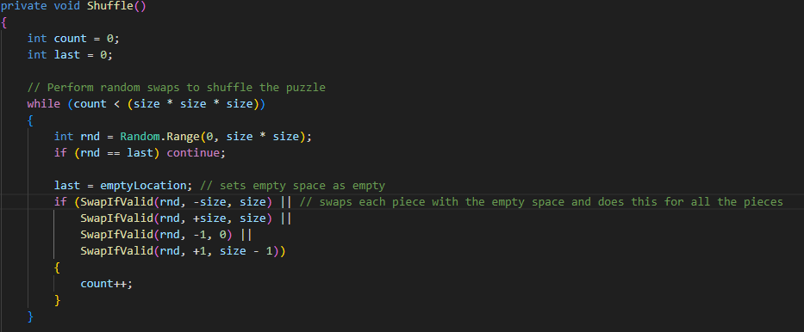

## Adding a Score Counter

I wanted to add a piece of persistent data, and decided to do health points, however there was nothing in my game that could have reduced the players hit box so I opted for a score counter, which started off at 50000 and every minute it took went down by 1000, to add a bit of competitiveness to the game.

Testing input data- I had to make sure the score would not go below zero, and check the score was displaying the correct input, and I also checked the score went down the correct amount by every input such as 1000 from every minute, 5000 from a shuffle and 10 from each move.

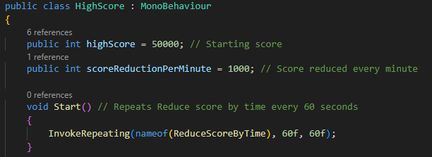

I then decided to add a move count that would reduce the score by 10, as an incentive to players to reduce their overall moves and further increase the competitiveness.

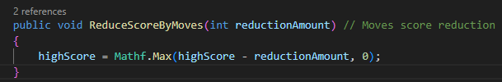

I thought that to reduce their moves as much as possible, players would repeatedly shuffle the puzzle until they got into a position that made it very easy for them to solve so I decided to add a large reduction in score if the user was to shuffle the puzzle, I added a 5000 point reduction for shuffling.

One issue I had with displaying my score was that the text box I attached the script into would not work, and I was not able to see the score once I had entered the game.

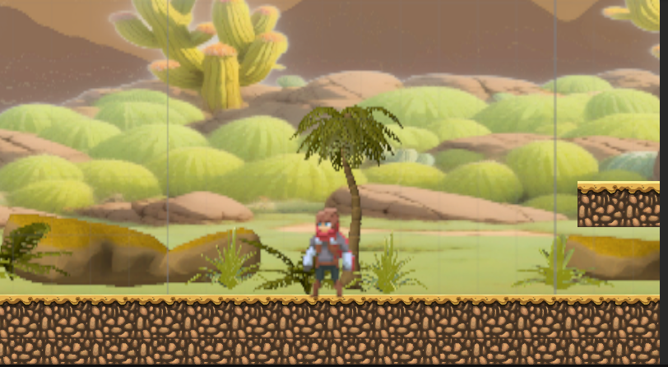

The score was supposed to show up in the middle however nothing was there. It ended up being an issue with attaching my script to the text box and I had spent a lot of time going through my script when it turned out to be attaching both of my scripts to the correct objects and the text box. It is now fully functional and shows up before you finish the game.

## Scenes

For my game, I needed 4 scenes because I wanted the game to be organised:

Splash Screen scene

Menu scene

Game Screen scene

End Game Screen scene.

These were all necessary so that I could organise my game, and to know where everything was. It also allowed me to make a nice UI

## Audio

At this point all the logic (aside from the UI), was complete so I went to search for some audio packs, for sound effects, I checked litch.io, however the assets I found, had an issue with importing them where it would always import as a video file and I could not fix it, even after multiple attempts and trying to find different audio files.

I tried checking the Unity Assets store however I could only find game music and no sound effects such as movement and UI. I imported an Ancient Egyptian themed sound pack, and it contained 4 different background music, which was perfect because it was the exact number of scenes that I had.

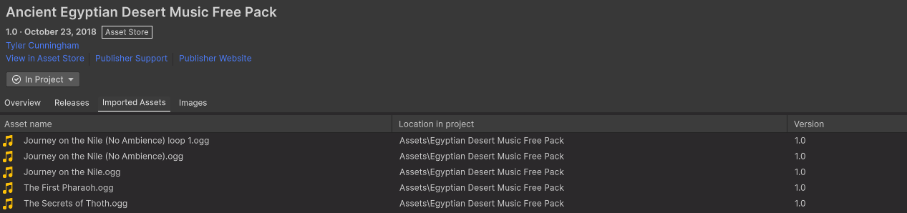One of the songs is a loop, hence why it shows up as 5 songs.

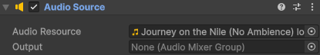

For my game scene I chose Journey on the Nile firstly because it matched the games Genre of ancient Egypt, but mainly because it matched the Scenes mood and would improve the player engagement.

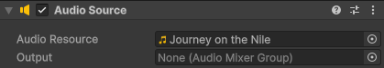

For my splash screen I also used Journey on the Nile, however I chose the version with a build up to the music, as it introduces the games' theme and engages the player from the start. I also chose it so that the transition into the menu and gameplay was smoother.

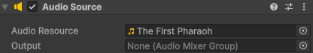

For my menu screen I chose The First Pharaoh, I had chosen a track with a steady beat to create a sense of wonder and adventure, to prepare the user for the game they are about to enter.

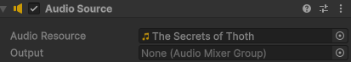

Finally, on my end game screen, I played a slow-paced track to relax the player after the game, as one of the goals in my game is to complete it in the fastest possible time, and having a slow song afterwards helps the user to relax afterwards.

## UI

### Menu- Play Button

I first began by creating a Play button, so that the user could load into the game scene, however before I did that, I first had to add a panel that would show the difficulties when I pressed the play button, and I did this by using a Boolean variable, so that once I pressed the play button, the menu would be set to false, and the difficulty panel would be set to true so that the user could view it.

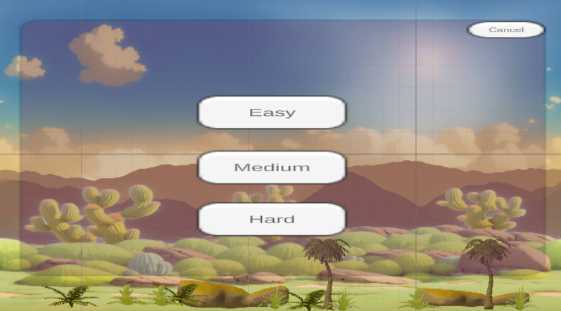

I unfortunately was unable to add any visual effects or import sprites to replace the buttons so that they would appear better due to a large time constraint.

Testing input data- I had to test the button by pressing it and making sure it performed the correct function.

Menu- Difficulty Panel

Now that the panel would show up, I had to make each button set the difficulty of the puzzle to the correct option and change the scene to the game scene, so that the user would be able to switch to the game scene with their selected difficulty.

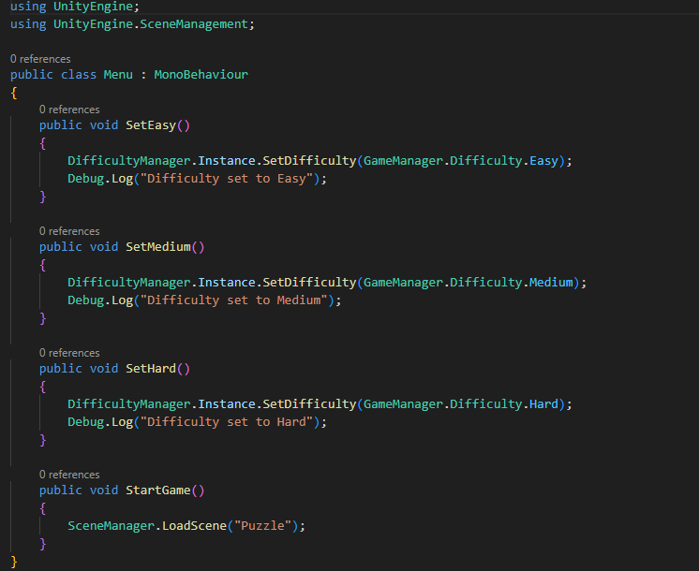

This script is used to set a variable that is then later used inside the puzzles script to select the difficulty of the puzzle, if it is selected to be easy, the puzzle is 3x3, if it is selected to be medium, it is 4x4, and if it is selected to be hard, it is 5x5.

After the specific difficulty is chosen, each button has a second function to also load the game scene afterwards.

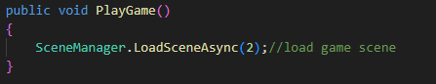

I then duplicated my play button, removed the functions and renamed it to options as this was quicker than making a new button. The option button did not require any script as it was just a Boolean variable and worked in the same way my play button did, to open a settings panel.

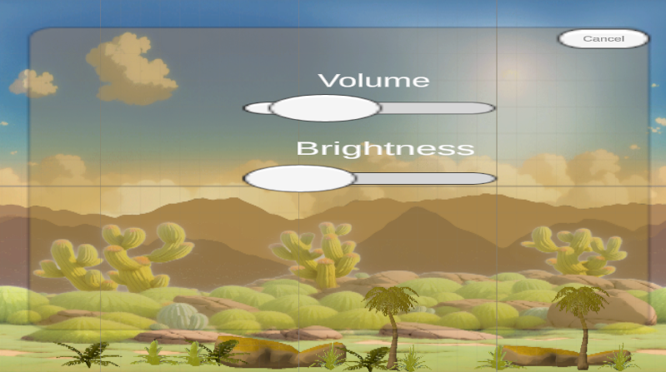

Just like the difficulty panel, in my settings panel, I was also unable to add any sprites to replace any of it due to major time constraints.

### Menu- Settings Panel

#### Settings Panel- Volume Slider

I wanted to add a settings panel so that there was a central place to change everything, rather than volume being somewhere, and brightness being someplace else, it is easier for the user this way. I began with trying to change my volume and originally, I opted for a volume up button and a volume down button. However, I saw a more time efficient option and since I was on a major time constraint I opted for a volume slider, so that I could reduce the amount of time I spent on making the option, it would also be simpler to use for the user, as they wouldn't have to switch between two buttons and rather just move the mouse left to right until they are satisfied with the volume. I did have an issue with implementation because the volume slider did not work for all my scenes but rather only my menu scene, and I could not make a new slider for each scene because it would not look good and would be very inefficient with time. After watching a YouTube video on volume sliders, I noticed it was an issue with my function and so I had to update it so that when it was used it would update the volume level for every scene and not just the menu scene.

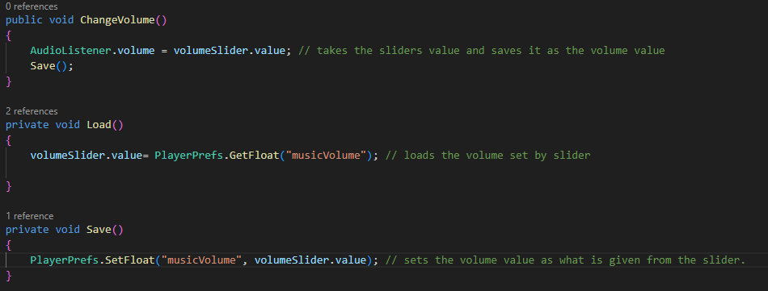

Testing input data- I had to test to make sure the volume slider changed the volume and nothing else, I also had to make sure it affected the other scenes.

#### Settings Panel- Brightness Slider

I wanted to do the same with brightness as well because sometimes the games are too bright, and since the game is out in the sun, the user may want to reduce the brightness so that they can see properly, however no matter what I did it would not work. I tried to check my code for any errors with the logic or syntax, I noticed a type error because for an unknown reason when it took the sliders input it had it translated into a string when it needed to be an integer so that the game would recognise the sliders movement.

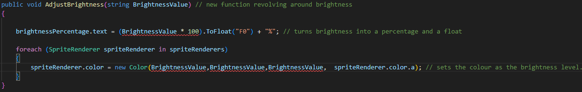

I fixed this but it would still not work, even after changing the settings and reconnecting everything in unity, I ended up looking online to see if anyone else has had this issue and if so how they managed to solve it, but it turns out with my game to adjust the brightness I need a light source for it to be changed and I did not have one, so technically the brightness setting was working however there was no light source for it to change so it appeared to be broken.

Testing input data- I had to test whether the brightness slider was working correctly and whether the brightness was changing with the slider's movement

### Menu-Cancel Button

Now although pressing the play button can open the difficulty panel, what if you decided the music was too loud and you wanted to close the panel and open the settings panel, but then once you opened the settings panel and sorted your volume you were unable to close the settings panel because there was no cancel button. After noticing that there was no way back button, I added a little cancel button in the top corner of the settings panel and difficulty panel so that the user could close the panel. Implementing this was very simple as there was no code involved. All I had to do was set the button with 2 Boolean functions which were to set the panel as false and set the menu as true. I did this for both panels.

Testing input data- I had to test the button by pressing it and making sure it performed the correct function.

### Menu- Quit Game Button

I made a quit game button so that the user could leave the game if they wanted to before the game begins or afterwards if they want. It is better than them having to close the game by pressing the X on the top of the screen as that takes a lot longer or could potentially prevent them from leaving if something were to go wrong. Implementation of this was also relatively simple because there was only one function and 2 lines of code.

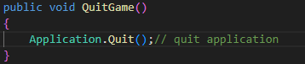

This is how my complete menu looks after implementing my Quit button:

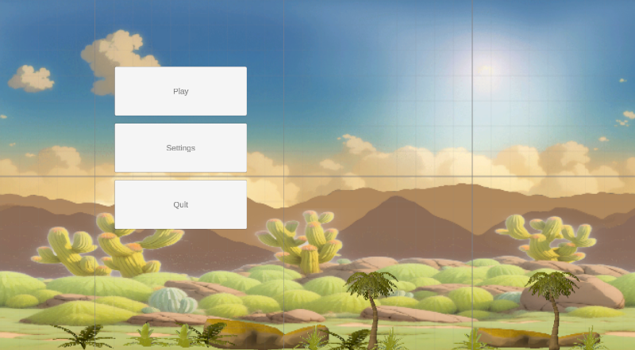

Now that the menu was completed, I only had 2 more things to do until all I had left was the designing of the obstacle course for the rest of the game.

Testing input data- I had to test the button by pressing it and making sure it performed the correct function.

## Splash Screen

I moved every scene up one place, and made the first scene the splash screen so that once the user loads up the game, the first thing they are introduced to is the splash screen, I did not design a display for it, instead I made a large button that covered the entire screen so that the user could easily switch to the menu scene. I changed the font to something nicer and typed up the name of the game and told the user how they could switch to the next scene. This feature was added to set the tone of the game and improve player experience by drawing them into it.



When the user hovers the mouse over the splash screen, it also changes colour. I did this to improve the appearance of the game.

Testing input data- I had to test the button by pressing it and making sure it performed the correct function. I also had to check that it came up when the game first started running.

## End Game Screen

I wanted the game to display a thank you screen to thank the user for playing the game, so once the user finishes the game and presses the end game button the screen changes to a new scene, where it displays the end game display.

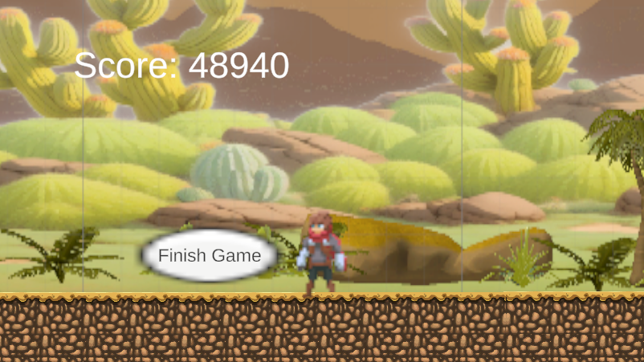

I wanted to use a button because of its simplicity when coding and how easy it is for the user to finish the game. It was relatively easy to implement and required very little code however it was a nice feature to introduce.

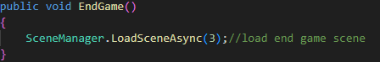

After pressing the Finish Game button, the end game scene is displayed, along with a nice, themed background that pairs very well with the objective of the game, as well as some nice music and a button that allows the user to return the menu if they wanted to replay the game or change the settings.

Testing input data- I had to test the button to make sure it switched the scene to the end game and the menu button to make sure it switched to the menu scene.

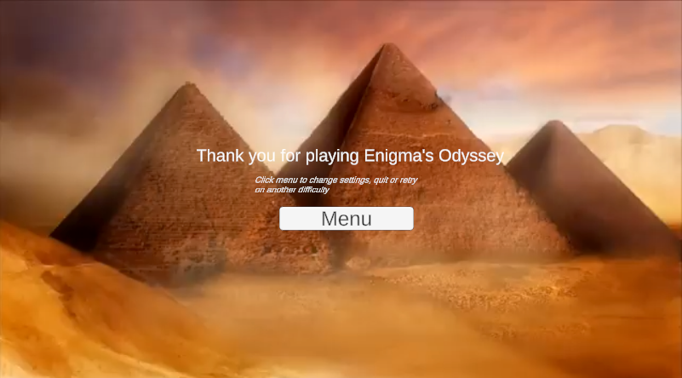

## Designing the stage

I had a goal of creating an obstacle course that the users would have to complete to finish the game, after solving the puzzle, to increase the gameplay variety as having a sole puzzle as the entire game would be relatively boring, and having a variety of things ensures that players remain engaged and entertained by introducing a different type of challenge. It also allows for replay ability, which may appeal to users who enjoy perfecting their skills or competing for the best times. There was no code involved in this and was solely me dragging and dropping blocks and building colliders on the obstacle courses.

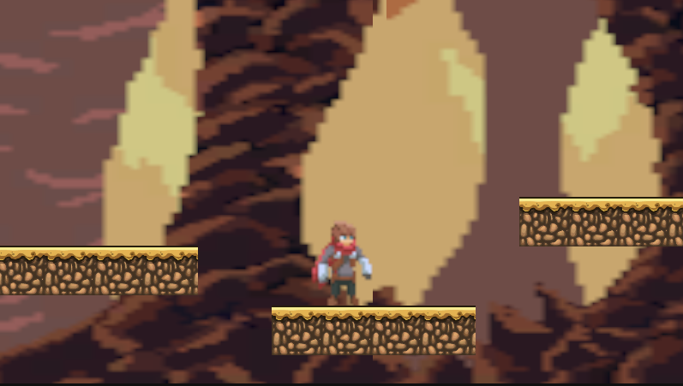

The feature where the obstacle course drops players into a cave was designed to create a sense of surprise and encourage exploration. This unexpected transition keeps players engaged by introducing a new environment. Dropping into the cave prevents it from feeling repetitive by changing the environment in the middle of the obstacle course, and pushes players to figure out a way out of the cave, which leads to another cave drop into another environment, pushing the players even harder to navigate out of the cave, once they get high up enough, players are forced to make a decision to go either left or right, when one of the ways will drop them all the way back down back to where they started and the other is the way out of the cave.

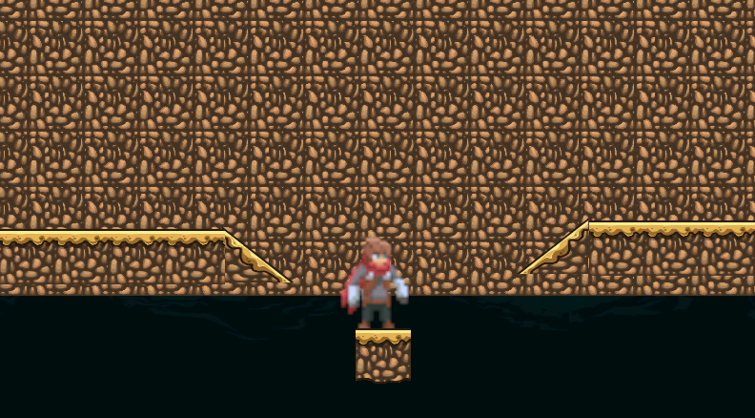

Once the user finally leaves the cave they can see their score, which is given based on the number of moves they made in the puzzle, the number of shuffles they used and the time it took for them to complete everything. They also get the option to finish the game where it takes them to the end screen so that they can either replay or change the settings.

Testing input data- I had to test that the stage had the correct colliders and that you couldn't move through any objects that you were not supposed to.

## Animations

Finally, before beginning refining and testing, I wanted to add animations to improve the users experience, as adding animations improves the visual quality of the game, having the extra detail in some things can change the users experience and encourage them to play the game more, potentially promoting reusability. I began by setting up an animator and animation tab. On my animation tab I created an animation for moving left and right, and dragged everything into the tab

This was my animation for walk, and it had 3 different frames that were split up over half a second to create the animation

This was my animation for Idle, and it had 4 frames this time that were split up over ¾ of a second.

This was my animation for Jump, and it had 3 frames for when the character is ascending, and 2 for when the character is descending.

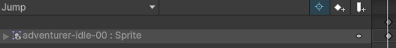

With my jumping animation I had to combine all of the frames into one as there is not a set time for it to be jumping and falling because of my mechanic which allowed the user to hold the jump button to move higher, this complicated things a little bit but it was worth the trouble.

## Implementing Animations

For the animations to work together I had to use an animator screen to connect all the animations. I began by setting idle as the default animation so that it happens when the user is not moving the character by default. The rest of the animations had to be implemented using the animator tab provided by unity and using a script.

I connected each animation to the other before beginning coding and set the time it takes for each animation:

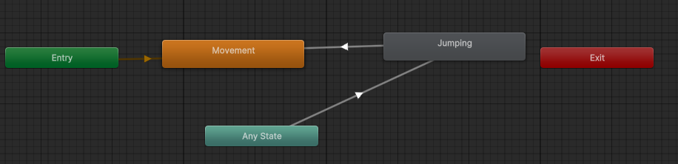

Now that every animation was connected to the other, I had to implement it using a script. I decided to attach the code for the animations onto my character movement script since they were for the characters movement. The isJumping state is what allows the ascending animation to work because unless the user has stopped holding down the space bar to continue going up, or the timer set for the jump has ended, the ascending animation will keep playing until the timer has ended or the user has let go of the jump button and when that happens the descending animation will play until the users foot circle has come into contact with the ground, then the idle animation will play unless the user is still moving left or right once they make contact with the ground.

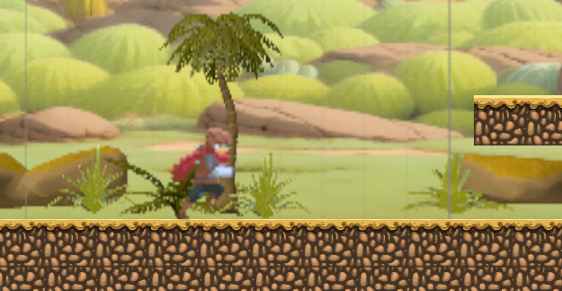

The xVelocity variable takes an input from the previous variable that checks if an input from the keyboard has been received, in which case it will give the value of 1, 0 or –1. If it is 1 or –1 the movement animation will play and it doesn't matter on the direction because the flipping the character section I did previously automatically fixes the direction of the animation.

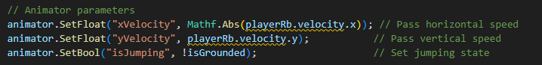

Testing input data- I had to test to make sure the animations were working functioning correctly and would not trigger if the wrong input was used. I tried different keys to make sure the animations were not triggered incorrectly and tested the correct keys to make sure the animations were triggered correctly.

## Refinement

Before moving onto testing, I wanted to review the obstacle and its design, because some of the parts were not possible, as the jumps were either too high or too far away for the character to reach, and I also had to fix some colliders since the character would sink halfway into the platform which was a major issue.

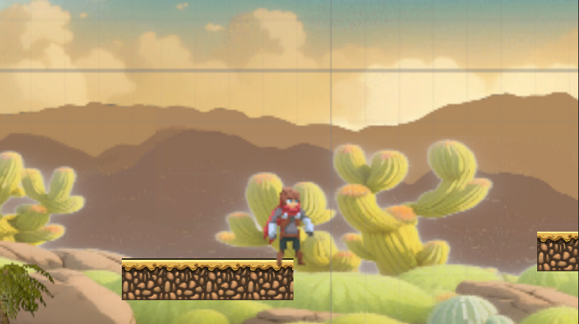

Here is an example of this, the jump is too far for the user to make, I also noticed that some of the platforms had a weird black line above them which I ended up having to remove.

# Evaluation

## Usability Features

### Menu Navigation

This game features a main menu that includes options like: New Game, Difficulty Select, Settings, and “Quit”. The buttons are appropriately labelled and very easy to access using the mouse. Keyboard navigation is not implemented yet, which means the player will have to rely on a mouse to navigate this menu.  
  
Aaron Gregory tested this feature and found everything fine. The menu buttons were normal to click, and the transition between different menu screens was smooth. He added that keyboard navigation will be enhancing accessibility since presently players cannot use arrow keys or “Enter” to select any options.

### Difficulty Selection

It has three difficulties: Easy (3x3), Medium (4x4), and Hard (5x5). Players can select the difficulty in the main menu before the game begins, and it automatically updates dynamically.  
  
Aaron Gregory confirmed that the difficulty settings were working, from changing the grid size of the puzzle depending on the setting. He said that in-game, there is no indication of what difficulty has been selected; therefore, players can't easily tell what mode they are playing on once the puzzle has started. This may be improved by showing what the current difficulty is somewhere on screen.

### Puzzle Interaction

Puzzle pieces can be clicked to move. Only valid moves, however, are allowed. The puzzle is shuffled at the start and can be reshuffled by pressing "R".  
  
Aaron Gregory tested this and found that the movement logic was working as expected: pieces could only move if they were next to the empty space, which prevented any accidental movements. However, he noted that the pieces instantly teleport rather than smoothly sliding into place. Adding an animation would make the movement feel more natural and visually appealing.

### High Score System

The game starts with a score of 50,000, taken away from over time and moves. Each minute, the player loses 1,000 points, 10 points with every move, and 5,000 points with every reshuffle.  
  
Aaron Gregory tested it and found that the high score updated accordingly, and the penalties did apply as needed. However, he pointed out that when the score changed, there is no feedback to show this, and it simply changes in the UI with no indication to the player. This could be improved by a simple animation or a sound when points are deducted.

### Camera Switching

The game's code currently allows players to toggle between a camera that follows a character and another that focuses on the puzzle by pressing "E" to move it on the puzzle and back on the player.  
  
Aaron Gregory confirmed indeed that the camera was working, and that the camera switched from one to another. However, this is a very sudden transition, so the switch feels a bit stiff. Adding a transition effect would make this flow better.

### Game Completion Feedback

The game detects when the puzzle is solved and outputs a message into the terminal.  
  
Aaron Gregory tested this and said that the game does indeed detect when the puzzle is complete. However, he mentioned that there is no real indication of success, no pop-up, sound, or animation to let the player know. A completion message or celebration effect would be more satisfying.

## Stakeholder Post-trial Questions

(Given to people who have already tried and tested Enigma’s Odyssey)

1) What did you enjoy most about the game?

2) What aspects of the game did you find frustrating or difficult to understand?

3) Did the game keep you engaged? If not, why?

4) Were the puzzles challenging enough for you? Too easy or too hard?

5) How can the puzzle design be improved to enhance your experience?

6) Were the controls intuitive and easy to use?

7) Did the sound effects and music improve your experience?

8) Was the user interface clear and easy to navigate?

9) Did you encounter any issues or confusion with the menus or in-game prompts?

10) How can the user interface be improved?

11) How would you rate your overall experience with the game?

12) What is the one thing you would change to improve the game?

13) Would you recommend this game to others? Why or why not?

14) Are there any features you feel are missing that would improve your experience?

#### Interview-1 Aryan Soni

Gaming for 12 years, experienced puzzle solver:

1. The easy to navigate UI.
2. The jumping was very weird and took me longer than necessary to understand.
3. I could not play it for longer than 20 minutes because it is very repetitive.
4. They were relatively easy to complete and took me around 15 minutes on medium difficulty.
5. Add animations to the puzzle.
6. The controls were quite easy to use, and I liked the controls guide page that pops up when clicked on to guide you.
7. The music helped to set the scene of Ancient Egypt and boosted the atmosphere inside the game.
8. The UI was extremely easy to use and navigate through.
9. There were no problems except for the brightness settings that did not work for me, which really affected my experience of the game as I could not see the colours properly.
10. I do not think there are many improvements that can be made to the UI as it was relatively easy to navigate and use.
11. I would rate my overall experience with the game an 8/10, because as easy as the UI was to navigate, the puzzles were quite repetitive, and the colour-blind filters were not functional.
12. I would add a more diverse range of puzzles to keep the player engaged in the game.
13. I would recommend the game because of how much I enjoy puzzle solving, and although they were easy to complete, I still enjoyed solving them.
14. I feel like NPC’s are missing from this game, just a character that you can interact with and to guide you around.

#### Interview-2 Daniel Forey

Gaming for 8 years, inexperienced puzzle games player:

1) The smoothness of the movement of the character.

2) I could not get around jumping because of the gravity being different to most games.

3) Not really, as there was not as much content as I would have hoped, and this caused me to finish the game quite quickly.

4) I struggled quite a bit with the puzzles as I do not regularly play puzzle solving games, which made my experience a bit more difficult than most.

5) Adding a hint bar somewhere on the screen to help players would make the game a lot more fun as you would not be stuck in the same area for too long.

6) The controls were extremely easy to use, and I did not have any problems with them.

7) I found the sound to be very annoying, as I could not focus on the puzzle because of the loud sounds, but thankfully there was an option to reduce the volume.

8) Yes, I had no problems with the UI, and it was easy to use.

9) I had no problems with the menu or in-game prompts.

10) It would appear a lot better if it matched the theme and was not just blank boxes.

11) I would rate my experience a 7/10 because it was fun to play but I found the puzzle quite difficult.

12) Nothing much, just to add a hints box and more content to the game.

13)No, I feel like there are much better alternatives out there, and I feel like the game was poorly built because of the lack of NPC’s and content.

14) Nothing specific, just a help bar and some more content.

## Testing For the Evaluation

|  |  |  |  |  |
| --- | --- | --- | --- | --- |
| Tests | Input | Expected outcome | Actual Outcome | Pass/Fail |
| Main menu should load after splash screen | Switch to main menu | Menu screen with Play, Options, and Quit buttons is displayed | As expected | Pass |
| Selecting "Play" starts the puzzle game | Click "Play" | Puzzle scene loads with default difficulty | As expected | Pass |
| Difficulty selection updates the puzzle size | Click Easy, Medium, or Hard | Puzzle changes to 3x3, 4x4, or 5x5 grid accordingly | It does not function from within the game however can be manually changed by changing the variable. | Partially working |
| Puzzle starts shuffled | Load game scene | Tiles are randomly arranged | As expected | Pass |
| Puzzle movement works as intended | Click a tile next to the empty space | The tile moves into the empty space | As expected | Pass |
| Move counter increments correctly | Click a tile to move it | Move count increases by 1 | As expected | Pass |
| High Score decreases with each move | Click a tile | Score decreases by 10 | As expected | Pass |
| Pressing "R" reshuffles the puzzle | Press "R" | Puzzle resets to a new shuffled state | As expected | Pass |
| Pressing "F" solves the puzzle | Press "F" | Tiles arrange in the correct order | Did not work, a few pieces or rows would move to the correct places but there would always be an error somewhere. | Partially working |
| High Score decreases by 5000 on reshuffle | Press "R" | High score reduces by 5000 | As expected | Pass |
| Completing the puzzle set “puzzleComplete” to true | Solve puzzle | puzzleComplete = true | As expected | Pass |
| Camera moves to puzzle view when pressing "E" | Press "E" | Camera moves to puzzle position | Works but is an instant transition | Mostly working |
| Camera moves back to player when pressing "E" | Press "E" | Camera follows the player again | Works but is an instant transition | Mostly working |
| UI displays current High Score correctly | Start game | High score is visible and updates | As expected | Pass |
| UI displays move counter correctly | Move a tile | Move count updates in UI | As expected | Pass |
| Back to menu button works | Click "Back to Menu" | Returns to main menu scene | As expected | Pass |
| Quit button exits the game | Click "Quit" | Game closes | As expected | Pass |
| Keyboard navigation for menus | Press arrow keys and Enter | Menus should be navigable without a mouse | Does not function | Fail |
| Brightness slider adjusts screen brightness | Move brightness slider | System brightness changes | Does not function as expected, as there are no light sources for it to adjust, however the script is fully functioning if there were light sources. | Partially working |
| Volume slider adjusts game audio | Move volume slider | Game sound levels adjust | As expected | Pass |
| Completion message appears after solving puzzle | Solve puzzle | A pop-up or notification should appear | Does not function | Fail |
| Reshuffling resets move count | Press "R" | Move count should return to 0 | Does not function | Fail |
| Selecting difficulty in menu persists in-game | Select difficulty in menu, then start game | Selected difficulty should be applied | Does not function as expected. | Partially working |

## Issues Identified and Potential Improvements

### Difficulty Selection Not Updating Properly

Issue- The game does not update to the selected difficulty unless the variable is changed from outside the game.

Improvement- Ensure the SetDifficulty() method properly applies the difficulty settings before the puzzle is created.

### Lack of Smooth Transitions for Camera Switching

Issue- The camera instantly jumps between views, making the switch feel sudden.

Improvement- Implement a transition to smoothly switch between positions.

### No visual/ audible feedback for puzzle completion

Issue- The game does not indicate to the user when the puzzle is completed.

Improvement- Add a “Puzzle Complete!” message, sound effect, or animation when the puzzle is solved.

### Brightness slider doesn’t work

Issue- Adjusting the brightness slider does not affect the games brightness.

Improvement- Add in a light source that can be affected by the brightness slider.

### Move count not resetting after reshuffle

Issue- When reshuffling the puzzle, the move count does not reset

Improvement- Add moveCount = 0 inside the Shuffle() function.

### Menu Navigation with keyboard not implemented

Issue- The menu can only be navigated with a mouse, which limits accessibility.

Improvement- Implement arrow key navigation and enter to select for the buttons in the UI.

## To what extent does the solution meet the success criteria?

This section evaluates the solution against the initial requirements defined during the planning stage. It discusses whether the requirements were met, partially met, or not met, along with justifications and potential improvements.

|  |  |  |
| --- | --- | --- |
| Requirements | Justification | Has it met the criteria? |
| Start-up screen with menu options | The game has a menu screen with "Play," "Options," and "Quit" buttons, ensuring the user can navigate the game effectively. | Yes |
| Difficulty selection (Easy, Medium, Hard) | Implemented successfully, allowing players to choose between 3x3, 4x4, and 5x5 puzzles. | Yes |
| Puzzle shuffling on start-up | The puzzle now shuffles as soon as the game starts, preventing an already solved puzzle from appearing. | Yes |
| Puzzle piece movement restricted to adjacent tiles | This is to prevent invalid moves and to improve puzzle functionality and realism. | Yes |
| Move counter implemented | A counter tracks the number of moves made by the player which is displayed in the UI for feedback. | Yes |
| High score system based on time and moves | The game starts with 50,000 points, reducing over time and per move. A penalty of 5000 points is deducted for reshuffling. 10 points for every move, and 1000 for each minute taken. | Yes |
| Puzzle completion detection | The game recognises once the puzzle has been solved and outputs it into the terminal, however the user is unaware once they have solved it because of a lack of sound effects, animations or text display. | Not fully implemented |
| Camera movement toggle | The player can press "E" to focus on the puzzle and “E" to return to the character. I am planning on adding in animations to make the transition between the player smoother. | Yes |
| UI displays the correct information | The move counter, high score, and difficulty settings are displayed | Yes |
| Button to return to the menu | After game has been completed, the player can go to the end screen using a button | Yes |

## Testing- “Connell Dawson”

I wanted to try a form of black box testing where I gave the software to another person, with none of the code and asked them to test it to search for any existing bugs. I chose Connell Dawson to carry out this form of testing for my game.

After a week of testing and trials, Connell came back to me with different errors he had found, and I had a think of possible solutions of the bugs and whether I could implement the solutions within my time frame. The problems included:

He suggested that the puzzle should be moved to the side and that I placed the target image on the side of the puzzle so that the users are aware of what they must arrange the puzzle into, making the objective clearer to the user. Based on this feedback, I made the puzzle smaller and moved it to the right, so that I could put the image of the complete puzzle to its right, making it clearer when solving.

He was also able to skip through the obstacle course by just walking through it to the end because I had a lack of colliders to prevent this from happening. From his feedback, I have now added multiple colliders in place to prevent this from happening again.

Connell also found another bug where the users could jump up the colliders and skip the obstacle course again, and this happened because the layer of the collider was ground, allowing for the character to be able to jump off the collider constantly, all the way up to the end. From the feedback I changed the layer to the default one to stop the user from being able to move up the collider.

## Maintenance

### Current and Future Maintenance

At the moment there are no automation features for upkeep in the game. However, I do understand that if this were a fully published game, upkeep would be necessary for fixing bugs or making new changes to the game.

At this stage, anything that needs further development or upkeep is done manually and the changes introduced are checked for through the trial-and-error method. In the case of an obstacle, I investigate the error messages, analyse logs, and do any required changes to scripts to get the desired output. Also, changes in the game logic, user interfaces, and game speed are altered in the code directly to try to optimize the game for better performance.

To improve the long-term maintainability of the game, I would implement the following features:

Update System- A feature in the main menu allowing users to check for and download updates to ensure the game remains up to date.

Bug Reporting System- A simple feedback form integrated into the game, allowing players to report issues, which can then be addressed in future patches.

Additional Features & Content- Depending on player feedback and the game’s reception, I may introduce additional levels, challenges, or mechanics to maintain user engagement over time.

## Limitations and How They Would Be Approached

I have created a list of limitations and how I would address them in the future.

|  |  |  |
| --- | --- | --- |
| Requirement | Justification | Approach |
| Switching the difficulty Mid-Game | Some players might find the puzzle too difficult or too easy and may want to switch the puzzle to another difficulty so that they don’t get bored and quit the game. | To fix this, I would implement a system where changing the difficulty of the puzzle will update the puzzle and reset it automatically. |
| High score system improvements | The high score system currently does not store high scores and as a result players are not able to compare past performances. | To improve this, I would implement a persistent storage system using a file saved on the computer of the user, allowing players to track their progress over multiple attempts. |
| Camera switching enhancement | The current camera transition is very quick and sudden and does not provide a smooth transition between the player and the puzzle. | To improve this, I would implement a script to the camera which slowly moves it to its destination rather than instantly teleporting it. |
| UI and accessibility features | The game lacks accessibility features such as colourblind modes, audio adjustments (aside from volume control), and | To make the game more accessible. I would implement settings for colourblind friendly modes and customizable controls. This would allow players with different needs to customize the game to their own needs. |

## What I would have done differently

If I were to restart my NEA, I would have done more to refine and expand my project, especially if there were no time constraints. I would have implemented features like difficulty switching, persistent high scores, and improved the accessibility options. However, my limited programming knowledge and other A-levels restricted the complexity of what I could create. While I successfully built a functional game, certain things, such as more efficient puzzle shuffling algorithms and smoother UI transitions, were beyond my initial skill level. With more experience, I could have structured my code better and incorporated advanced mechanics to improve the overall user experience.

## References

<https://www.youtube.com/watch?v=2iqfuv6bPYQ&list=PLSR2vNOypvs5_wVgPrVmhCYOfAE__MKcs&index=1&pp=iAQB> <https://www.youtube.com/watch?v=Ov40_jAKrMk&list=PLSR2vNOypvs5_wVgPrVmhCYOfAE__MKcs&index=2&pp=iAQB> <https://www.youtube.com/watch?v=gsmNcl3f-RA&list=PLSR2vNOypvs5_wVgPrVmhCYOfAE__MKcs&index=3&pp=iAQB> <https://www.youtube.com/watch?v=HbLCzsrmCyE&list=PLSR2vNOypvs5_wVgPrVmhCYOfAE__MKcs&index=4&pp=iAQB> <https://www.youtube.com/watch?v=T4izce4OISs&list=PLSR2vNOypvs5_wVgPrVmhCYOfAE__MKcs&index=5&pp=iAQB> <https://www.youtube.com/watch?v=4KIa1LtLZLo&list=PLSR2vNOypvs5_wVgPrVmhCYOfAE__MKcs&index=6&pp=iAQB> <https://www.youtube.com/watch?v=ElFjmd0Ou8w&list=PLSR2vNOypvs5_wVgPrVmhCYOfAE__MKcs&index=7&pp=iAQB> <https://www.youtube.com/watch?v=Gm-TnPakWwU&list=PLSR2vNOypvs5_wVgPrVmhCYOfAE__MKcs&index=8&pp=iAQB> <https://www.youtube.com/watch?v=IgBjJ-bexeo&t=624s&pp=ygUUcHV6emxlIGdhbWUgaW4gdW5pdHk%3D> <https://www.youtube.com/watch?v=DX7HyN7oJjE&t=198s> <https://www.youtube.com/watch?v=N8whM1GjH4w&t=430s> <https://www.youtube.com/watch?v=G-JUp8AMEx0> <https://www.youtube.com/watch?v=E25JWfeCFPA> <https://www.youtube.com/watch?v=HwVw5j8wxPg> <https://www.youtube.com/watch?v=IxHPzrEq1Tc> <https://www.youtube.com/watch?v=ZYZfKbLxoHI> <https://www.youtube.com/watch?v=POq1i8FyRyQ> <https://www.youtube.com/watch?v=O_3YsVHoWaY> <https://www.youtube.com/watch?v=fP1ulGcZhHE> <https://www.youtube.com/watch?v=4fvQUK2pPds> <https://www.youtube.com/watch?v=B40xBPXK97A&list=PLIvwrsXuTVRCMOtbhN-oRf8U8wba-Y0t7> <https://www.youtube.com/watch?v=AzItMI583kY&pp=ygUdaG93IHRvIGltcG9ydCBhc3NldHMgaW4gdW5pdHk%3D> <https://www.youtube.com/watch?v=jjn0uP2NF3s&pp=ygUcaG93IHRvIGltcG9ydCBhdWRpbyBpbiB1bml0eQ%3D%3D> <https://www.youtube.com/watch?v=mvaUho_a-q4&pp=ygUiaG93IHRvIGltcG9ydCBzb3VuZCBwYWNrcyBpbiB1bml0eQ%3D%3D> <https://www.youtube.com/watch?v=EjOT4Ni4uJA&pp=ygUpaG93IHRvIGNyZWF0ZSBhbiBvYnN0YWNsZSBjb3Vyc2Ugb24gdW5pdHk%3D> <https://www.youtube.com/watch?v=j48LtUkZRjU&list=PLPV2KyIb3jR5QFsefuO2RlAgWEz6EvVi6&index=1&pp=iAQB> <https://www.youtube.com/watch?v=IlKaB1etrik&list=PLPV2KyIb3jR5QFsefuO2RlAgWEz6EvVi6&index=2&pp=iAQB> <https://www.youtube.com/watch?v=9ZEu_I-ido4&list=PLPV2KyIb3jR5QFsefuO2RlAgWEz6EvVi6&index=3&pp=iAQB> <https://www.youtube.com/watch?v=Au8oX5pu5u4&list=PLPV2KyIb3jR5QFsefuO2RlAgWEz6EvVi6&index=4&pp=iAQB> <https://www.youtube.com/watch?v=HVB6UVcb3f8&list=PLPV2KyIb3jR5QFsefuO2RlAgWEz6EvVi6&index=5&pp=iAQB> <https://www.youtube.com/watch?v=gAB64vfbrhI&list=PLPV2KyIb3jR5QFsefuO2RlAgWEz6EvVi6&index=6&pp=iAQB> <https://www.youtube.com/watch?v=D4I0I3QJAvc&list=PLPV2KyIb3jR5QFsefuO2RlAgWEz6EvVi6&index=7&pp=iAQB> <https://www.youtube.com/watch?v=TAGZxRMloyU&list=PLPV2KyIb3jR5QFsefuO2RlAgWEz6EvVi6&index=8&pp=iAQB> <https://www.youtube.com/watch?v=VbZ9_C4-Qbo&list=PLPV2KyIb3jR5QFsefuO2RlAgWEz6EvVi6&index=9&pp=iAQB> <https://www.youtube.com/watch?v=Iv7A8TzreY4&list=PLPV2KyIb3jR5QFsefuO2RlAgWEz6EvVi6&index=10&pp=iAQB> <https://www.youtube.com/watch?v=r5NWZoTSjWs&list=PLPV2KyIb3jR5QFsefuO2RlAgWEz6EvVi6&index=11&pp=iAQB>

# Code Listings

